Please use the “Word modification tracking mode” so that corrections will be easier to make. Thanks

Interpretation and Use of Instrument Measured
Cotton Characteristics
A Guideline by
ITMF International Committee on
Cotton Testing Methods (ICCTM)
And by
ICAC Task Force on Commercial Standardization
of Instrument Testing of Cotton (CSITC)

Editors and contributors:
- Jean-Paul Gourlot, CIRAD, UPR AÏDA, F-34398 Montpellier, France, and AÏDA, Univ Montpellier, CIRAD, Montpellier, France.
- Axel Drieling, Faserinstitut Bremen e.V. (FIBRE) / ICA Bremen, Bremen, Germany.
- Mona Qaud, Uster Technologies, Uster, Switzerland.
- Stuart Gordon, CSIRO, Geelong, Australia.
- Jimmy Knowlton, USDA AMS, Memphis, USA.
- Malgorzata Matusiak, Lodz University of Technology, Lodz, Poland.
- René van der Sluijs, Textile Technical Services, Geelong, Australia.
- Vikki Martin, Cotton Incorporated, Cary, USA.
- Karsten Froese, Bremer Baumwollboerse, ICA-Bremen, Bremen, Germany.
- Chris Delhom, USDA-ARS-SRRC, New Orleans, USA

Published by:
- International Cotton Advisory Committee (ICAC), Washington, D.C., USA
- International Textile Manufacturers Federation (ITMF), Zurich, Switzerland

This publication is available at:
- www.csitc.org
- www.icac.org
- www.itmf.org
- www.cirad.fr (to get the ISBN ref. number)

Date of issue: Vxx.x – Date, 2019

 | 
International Cotton Advisory Committee | International Textile Manufacturers Federation
1629 K Street NW, Suite 702,  Washington DC 20006  USA  Telephone +1-202-463-6660  Fax +1-202-463-6950  e-mail: secretariat@icac.org | Wiedingstrasse 9  CH-8055 Zürich  Switzerland  Telephone +41-44-283-6380  Fax +41-44-283-6389  e-mail: secretariat@itmf.org
Task Force on Commercial Standardization of Instrument Testing of Cotton (CSITC) | International Committee on  Cotton Testing Methods (ICCTM)

Bibliographic reference:
Gourlot Jean-Paul, Drieling Axel, Qaud Mona, Gordon Stuart, Knowlton James, Matusiak Malgorzata, van der Sluijs René, Martin Vikki, Froese Karsten, Delhom Chris, 2020. Interpretation and use of SITC measured characteristics, Version 0.76b issued November 22, 2019, English edition, a guideline by ICAC Task Force on Commercial Standardization of Instrument Testing of Cotton (CSITC) and by ITMF International Committee on Cotton Testing Methods (ICCTM), 72 p., ISBN zzzz.

Book edition by: Gourlot Jean-Paul and Drieling Axel
Cover edition by: Cotton Incorporated Public Relation Team

Content
1 - Preamble 4
2 - Introduction 5
3 - Description of the main processing steps supply chain in the cotton and textile industry and stake of quality management along the supply chain 7
4 - Management of the given natural variability of material quality characteristics to produce uniform materials 8
4.1 - Sources for result variation 8
4.2 - Quantification of within-sample test result variation and within-bale result variation 10
4.2.1 - Quantification A: Within-instrument variation on one sample, based on CSITC Round Trial data 10
4.2.2 - Quantification B: Within-instrument and within-bale variation on one sample, based on pre-tests performed on ICA Bremen Round Trial samples 11
4.2.3 - Quantification of variations between instruments 12
4.3 - Variation between bales within a lot 12
4.4 - Handling variability between bales and lots: use of bale laydown organization 13
4.5 - Use of test results: individual results vs mean results 18
5 - Micronaire 20
5.1 - Unit, range, significance in CSITC harmonization process 20
5.2 - Existing measuring instruments for measuring micronaire 22
5.3 - Description of any relation between ‘manual and visual grading’ and ‘instrument classing’ evaluation results 23
5.4 - Evaluation results present in ‘manual and visual grading’ but missing in ‘instrument classing’ evaluation results 24
5.5 - Use of Micronaire results for cotton production 24
5.6 - Use of Micronaire results in ginning 24
5.7 - Use of Micronaire results for trading 25
5.8 - Use of Micronaire results for spinning mills / textile processing 25
6 - Length measurement 27
6.1 - Unit, range, significance in CSITC harmonization process 27
6.2 - Existing measuring instruments for measuring length parameters 29
6.3 - Description of any relation between ‘manual and visual grading’ and ‘instrument classing’ evaluation results 29
6.4 - Evaluation results present in ‘manual and visual grading’ but missing in ‘instrument classing’ evaluation results 29
6.5 - Use of Length results for cotton production 30
6.6 - Use of Length results in ginning 30
6.7 - Use of Length results for trading 30
6.8 - Use of Length results for spinning mills / textile processing 30
7 - Strength measurement 32
7.1 - Unit, range, significance in CSITC harmonization process 32
7.2 - Existing measuring instruments for measuring strength 33
7.3 - Description of any relation between ‘manual and visual grading’ and ‘instrument classing’ evaluation results 34
7.4 - Evaluation results present in ‘manual and visual grading’ but missing in ‘instrument classing’ evaluation results 34
7.5 - Use of Strength results for cotton production 34
7.6 - Use of Strength results in ginning 34
7.7 - Use of Strength results for trading 35
7.8 - Use of Strength results for spinning mills / textile processing 35
8 - Color measurement 36
8.1 - Unit, range, significance in CSITC harmonization process 37
8.2 - Existing measuring instruments for measuring color 39
8.3 - Description of any relation between ‘manual and visual grading’ and ‘instrument classing’ evaluation results 39
8.4 - Evaluation results present in ‘manual and visual grading’ but missing in ‘instrument classing’ evaluation results 40
8.5 - Use of Color results for cotton production 40
8.6 - Use of Color results in ginning 40
8.7 - Use of Color results for trading 40
8.8 - Use of Color results for spinning mills / textile processing 42
9 - Trash count and area 43
9.1 - Unit, range, significance in CSITC harmonization process 43
9.2 - Existing measuring instruments for measuring trash 44
9.3 - Description of any relation between ‘manual and visual grading’ and ‘instrument classing’ evaluation results 45
9.4 - Evaluation results present in ‘manual and visual grading’ but missing in ‘instrument classing’ evaluation results 45
9.5 - Use of Trash count and area results for cotton production 45
9.6 - Use of Trash count and area results in ginning 46
9.7 - Use of Trash count and area results for trading 46
9.8 - Use of Trash count and area results for spinning mills / textile processing 46
10 - Other measured parameters 48
10.1 - Spinning Consistency Index 48
10.2 - Amount 49
10.3 - Moisture 49
10.3.1 - Use of Moisture results in production 50
10.3.2 - Use of Moisture results in ginning 50
10.3.3 - Use of moisture content for trading 50
11 - Other characteristics that could be measured on fibers using other instruments 52
11.1 - Neps 52
11.1.1 - Unit, range, significance in CSITC harmonization process 52
11.1.2 - Existing measuring instruments for measuring Neps 53
11.1.3 - Description of any relation between ‘manual and visual grading’ and ‘instrument classing’ evaluation results 53
11.1.4 - Evaluation results present in ‘manual and visual grading’ but missing in ‘instrument classing’ evaluation results 53
11.1.5 - Use of neps results for cotton production 53
11.1.6 - Use of neps results in ginning 53
11.1.7 - Use of neps results for trading 54
11.1.8 - Use of neps results for spinning mills / textile processing 54
11.2 - Stickiness 55
11.2.1 - Unit, range, significance in CSITC harmonization process 55
11.2.2 - Existing measuring instruments for measuring stickiness 56
11.2.3 - Description of any relation between ‘manual and visual grading’ and ‘instrument classing’ evaluation results 56
11.2.4 - Evaluation results present in ‘manual and visual grading’ but missing in ‘instrument classing’ evaluation results 56
11.2.5 - Use of stickiness results for cotton production 56
11.2.6 - Use of stickiness results in ginning 57
11.2.7 - Use of stickiness results for trading 57
11.2.8 - Use of stickiness results for spinning mills / textile processing 58
12 - Interaction or relations between parameters 59
13 - Summarized information 60
14 - Lexical 62
15 - Acknowledgments 63
16 - List of illustrations 64
17 - List of tables 66
ANNEX A: Detailed explanation of Figure 2 (and similarly of Figure 3) 67

Preamble

Standardized high volume instrument testing is carried out widely today and is becoming more and more the basis for cotton trading instead of manual classing. The aim of the International Committee on Cotton Testing Methods of the ITMF (ITMF-ICCTM) is to encourage research and development into enhanced test methods and to harmonize cotton testing methods results. The aim of the ICAC Task Force on Commercial Standardization of Instrument Testing of Cotton (CSITC Task Force) is to facilitate instrument testing and the use of instrument results for commercial purposes.
To enable reliable and comparable test results from cotton testing laboratories worldwide, a universal and comprehensive manual, covering the best practices for commercial instrument testing of cotton fibers from sampling to data reporting, was produced jointly by the CSITC Task Force and the ITMF-ICCTM in 2012. It is maintained continuously as the “Guideline for Standardized Instrument Testing of Cotton”, hereafter referred as to ‘CSITC Testing Guideline’. The manual is available in several languages at:
- http://csitc.org/index.php?lien1=/instrument_testing/public_documents_it,
- https://www.icac.org/CommitteesandNetworks/SEEPDocuments?CommitteeLinkId=23
- http://www.itmf.org/committees/international-committee-on-cotton-testing-methods.
Going forward, the ITMF-ICCTM and CSITC Task Force then agreed to work jointly on this current Guideline, hereafter referred as to ‘ITMF-ICCTM and CSITC Interpretation Guideline’. This Guideline aims to explain how to interpret and apply results produced by a range of instruments used by the different segments of the cotton industry. The segments include measurements during seed-cotton production through to spun yarn and dyed fabric.

This document is only the temporary result of a work in progress that will evolve with its successive versions. These versions will be produced in the future, in particular based on the ideas, reflections, questions and comments that will be brought to us by readers and users. So please do not hesitate to come back to any of the contributors for future improvements of this document!

Many thanks in advance.

Introduction
Since the end of the 19th century, cotton fiber ‘quality’ evaluation and characterization have been performed for the two following major reasons:
- Cotton quality depends on plant genetics (variety) and production conditions, and these determine the price of cotton when it is transferred from one operator to the next within the cotton value adding chain.
- Fibre quality test results allow to predict of the performance of the cotton from ginning through to dyeing. This is particularly true when results are used in the management of both the cotton and the machines used to process it.
During the 1980s, combined instruments (often called ‘High Volume Instrument’ or 'HVI') lines have started replacing individual testing instruments, e.g., Micronaire, Fibrograph and Stelometer/Pressley instruments. The wording 'HVI' is now trademark protected and the following wording applies to high volume instrument lines: Standardized Instrument for Testing Cotton or SITC, as the testing method, parameters and calibration material have been standardized and harmonized for all according instruments.
As SITC test results are used in cotton production, ginning, trading and processing, and in the communication between all these steps, and as there is still much confusion between definitions and wordings in manual classing and instrument testing, it is important to have a common understanding of the test method and its results, suitable for all. Hence the ‘ITMF-ICCTM and CSITC Interpretation Guideline’ aims to define all technical words currently in use and at placing them into their context, i.e., their scope of application, use and limits of use, units, etc.
The CSITC Testing Guideline covers sampling and testing. This ‘ITMF-ICCTM and CSITC Interpretation Guideline’ follows up on the use/application of the test results, basing on the CSITC Testing Guideline and its definitions and explanations.
The properties and characteristic values considered in this Guideline are:
- Important SITC result parameters:
  - Micronaire (representing fineness and maturity)
  - Length (Upper Half Mean Length, Uniformity Index, and Short Fiber Index)
  - Strength (Strength and Elongation)
  - Color (Reflectance and Yellowness)
  - Trash (Count and Area)
- Other parameters, which are given by the instrument, but usually not considered:
  - Spinning Consistency Index
  - Amount
  - Moisture
- Other characteristics that can be measured on fibers using other instruments
  - Maturity
  - Fineness
  - Neps
  - Stickiness….
For each of these characteristics, the use and interpretation of measured results are described for:
- Cotton production (agronomic practice and harvest preparation)
- Ginning
- Trading
- Spinning and textile processing.
These descriptions take into account that cotton fibers, being a natural product, have highly variable characteristics within and between collected representative samples, and therefore that any measurement result carries an embedded un-precision and is surrounded by tolerances, themselves linked to the capacity of measuring instruments to properly, precisely, and timely measure differences when existing.

Description of the main processing steps supply chain in the cotton and textile industry and stake of quality management along the supply chain
The main processing steps in the cotton and textile industry are described in Figure 1.
The production pipeline starts with the sowing of cotton seed, production of the plant, harvesting of seed-cotton and its transportation to the gin.
In the gin seed-cotton can be cleaned before the fibers are separated from the seed and then possibly cleaned (via a lint cleaner). The cotton fiber (lint) is then compacted into bales for storage and transport to spinning mills. A fiber sample from each bale is taken for quality characterization (manual and/or instrumental classing). This step also enables the grouping of bales into lots based on quality characterization results for later trading, transport and processing.
The spinning process is designed to open, clean, homogenize and assemble fibers into yarns with the requirement of working with a constant set of characteristics with as little variation as possible in the raw material in order to maintain an almost constant set of characteristics for the produced yarns. Spinning is one of the processes where fibers, other than cotton, can be introduced into the production pipeline.
Weaving and knitting are the two main techniques to produce textile fabrics used in the textile industry. These are the steps where care should also be taken in the stability and the homogeneity of quality characteristics along time.
The dyeing and finishing operation are the final steps for producing fabrics ready for assembling into garments ready for final consumers at the confection step. These also are the operations where all quality management problems of the raw and transformed materials are usually revealed.

Figure 1: Cotton and textile supply chain: major materials flows.

Management of the given natural variability of material quality characteristics to produce uniform materials
Cotton fiber characteristics change for many reasons. The final properties of a bale are dependent on cotton variety, the type of cotton production (agronomic conditions as e.g. mechanization, growing conditions, harvesting technique or weather), on the organization of seed-cotton collection, of transport and storage and the type and set up of equipment in the gin. This will induce variability in fiber quality values at several levels: within the sample, within and between bales, within and between lots, and even throughout the season. In addition, the blending of several origins of cotton is standard in spinning mills, which can introduce a new source of variability that manufacturers have to manage whilst producing their goods.
The same situation applies to the weaving and or knitting industry, and steps beyond, where yarns, and then fabrics, have variable quality characteristics, which need to be considered in relation to the product to be made and the technology for producing them.
To control these multi-scale variability levels of material quality, several solutions can be used in isolation or in combination:
- Check, organize or control most sources of variability of material characteristics,
- Order raw materials within given fiber characteristics limits,
- Manage the given variability to avoid quality and productivity problems.
The scope of this control depends on the available information about materials; in connection with the CSITC Task Force and ITMF ICCTM objectives, we will concentrate on cotton fibers as raw materials:
- With manual / visual and instrumental classing information from bale samples, only some properties can be managed, unless new samples should be taken for performing instrument testing for basing the management of raw materials on new results;
- With additional instrument testing results, more measured characteristics can be used for managing quality, depending on the objective of production in terms of productivity and quality.

Sources for result variation
Test result variability arises because of variation in the:
- Test material (sample, see below) and
- Testing process; test method, calibration, operator/personnel, environment, instrument and auxiliary devices (these items are discussed in the CSITC Testing Guideline).
Unfortunately, it is sometimes difficult to distinguish between the variation from the material and that resulting from the test method itself, as both are simultaneously present in the final result. Therefore, any typical result includes both sources of variation. Thus variation in the test method should be kept at a minimum, although it is understood that it cannot be completely avoided, particularly when comparisons are made between laboratories.
Other sources of variation, e.g., material related test variability, are also considered in this document:
- Between single fibers;
- Between different test specimen of one sample, which also measures the testing variability as well as the material variability;
- Between different samples in a bale, either in the same or between layers, which also measures the within-bale variability and includes above levels of variability;
- Between different bales in a lot, which also measures the within-lot variability and includes above levels of variability;
- Between different lots, which also includes above levels of variability.
Each of these levels of observation allows the calculation of averages and standard deviations (Figure 2). One has to pay attention that these means and standard deviations carry more and more sources of variability as long as getting downstream in the process, from fibers to bale-lots. In any case, means and standard deviations should be compared with great care, as they depend on the basic numbers used to make the calculations, and only if a common calculation methodology was used in each situation. If needed, detailed explanation of Figure 2 and Figure 3 are given in Annex A.

Figure 2: Various calculation ways for Means and Standard Deviations (SD) in the case of bale management: Influence of the calculated mean and SD values (explanation in Annex A).
The following paragraphs provide data quantifying the importance of one or more sources of variation in the results limited to those of the material. When the source of variation depends on testing conditions, data is provided in the CSITC Testing Guide. The data provided hereafter depends on specific calculations that were obtained in the frame of round-tests or specific experiments; each of the data is made in reference to calculation modes labelled in Figure 3.

Figure 3: Various calculation ways for Means and Standard Deviations (SD) in the case of round-tests results: Influence of the calculated mean and SD values (explanation in Annex A).

Quantification of within-sample test result variation and within-bale result variation
It is important to get estimates for the levels of variation when determining the significance of a particular test result. By completing a higher number of tests (watch for incidence on testing costs) on one sample or bale layer, or on several samples from different positions of one complete bale, it is possible to quantify the test variation within samples on one hand, and between-samples and within bales on the other. These variations include material related variations as well as test related variations. Similar variation results can be achieved by analyzing single test data from Round Trials too, as seen in Figure 3.

Quantification A: Within-instrument variation on one sample, based on CSITC Round Trial data
Prerequisites:
- Only US Upland cotton samples. Bales chosen by USDA-AMS, trying to avoid bales with high variability (candidate bales).
- Each participating laboratory is testing its samples 6 times on each day on the same instrument.
- By repeating tests on 5 different days, it is in addition possible to quantify the test result variation between days (each day as an average of 6 tests), which are mainly influenced by testing conditions rather than material variation.
- As one lab receives one sample per bale, this within-sample variation is excluding the variation between different samples in a bale.
- With 120 to 160 instruments participating, the results are reported as the median of all within-instrument variations.
For Micronaire, Strength, Length, Length Uniformity, Color Rd and Color +b it is feasible to show standard deviations (Table 1). For SFI and Trash, as the variation is strongly increasing with the measured value, CV% are provided instead of Standard Deviations (Table 2).

Table 1: Within-Instrument Variation on one sample: Median within-instrument Standard Deviation (SD), averaged for 32 US Upland cotton samples from RT 2017-1 to 2018-4.
Within-Instrument Variation [given as Standard Deviations (SD)]
Characteristic | Mic | Str | UHML | UI | Rd | +b
Unit |  | g/tex | inch/mm | %
Variation between single test on one day  (which measures the within-sample variation) | 0.035 | 0.53 | 0.0099 inch  0.25 mm | 0.51 | 0.17 | 0.097
Variation between different days  (which measures the within-instrument variation) | 0.025 | 0.33 | 0.0055 inch  0.14 mm | 0.27 | 0.16 | 0.093

Table 2: Within-Instrument Variation: Median within-instrument Coefficient of Variation (CV%), averaged for 32 US Upland cotton samples from RT 2017-1 to 2018-4.
Within-Instrument Variation [given as Coefficient of Variation (CV%)]
Characteristic | SFI,  CV% | Trash Area, CV% | Trash Count, CV%
Variation between single test on one day | 4.8 | 16 | 13
Variation between different days | 2.6 | 13 | 10

Quantification B: Within-instrument and within-bale variation on one sample, based on pre-tests performed on ICA Bremen Round Trial samples
Prerequisites:
- Wide range of origins with wide range of growth, harvesting and ginning environments (here: Benin, Brazil, Ivory Coast, Greece, Guinea, Israel, Sudan, USA).
- Done as a pre-test for the ICA Bremen Round Trials.
- Tests in one laboratory and on one instrument.
- Test on one sample per layer, 10 layers per bale with one sample per layer, 6 tests per sample in one instrument in one laboratory on one day testing.

Table 3: Within-Instrument Variation on one sample: range of within-instrument Standard Deviation (SD) for eight Round Trial Sample Bales from ICA Bremen RT 2016-1 to 2018-2.
 | Micronaire | Strength | Length | Length
 | no unit | g/tex | mm | inch
Variation between single tests in one sample, SD | 0.02 to 0.09 | 0.6 to 1.6 | 0.29 to 0.73 | 0.01 to 0.03
Variation between bale layers, SD | 0.02 to 0.08 | 0.24 to 0.69 | 0.1 to 0.32 | 0.004 to 0.013

Quantification of variations between instruments
Up to this stage, solely the result variation based on typical single instruments has been regarded. As soon as results for the same bale are coming from different laboratories / instruments, the between result variation has to be considered in addition to the within-result variation.

Table 4: Table of between instrument variations as reported by the CSITC Testing Guideline (extracted).
Inter-instrument variations
(Average of the inter-instrument SD for 16 US Upland cotton samples)
Characteristic | Mic | Str | UHML | UI | Rd | +b
Unit |  | g/tex | inch | % |  | -
based on 30 tests per instrument | 0.057 | 0.71 | 0.010 | 0.46 | 0.52 | 0.27
based on 6 tests per instrument | 0.063 | 0.82 | 0.012 | 0.54 | 0.55 | 0.28
based on single tests | 0.072 | 0.96 | 0.015 | 0.73 | 0.60 | 0.32
For more information around these levels of variation please see CSITC Testing Guideline.

Variation between bales within a lot
Based on Figure 2, it is not possible to provide a valid variability level indication between bales within a lot, as lots may be defined as production lots or sales lots:
- The variability of production lots depends on how the lot, e.g., shipping container, is accumulated, e.g., the regional area from where the bales are accumulated, e.g., number of farms, varieties and cropping systems, through to the ginning procedure, e.g., the number of gins included in the lot and then gin type and machinery.
- Sales lots can be arranged for fitting best to production, sales or processing aspects, each resulting in very different variability levels.
Nevertheless, some samples for typical production lot variabilities can be given. This does not mean that the sales lots show according variations.
If that is possible, a future version of this Interpretation Guide will contain examples of the levels of variations at various scale in various growing regions. We call for volunteers.

Handling variability between bales and lots: use of bale laydown organization
As seen before, cotton characteristics and test results are variable at many levels. On the example of Micronaire, the management of between-bales variability while processing in a spinning mills is described hereafter.
Two main techniques exist for the opening of the bales (Figure 4) at the spinning mill:
- Usually, bales are prepared and consumed in batches or laydowns with the automatic bale opening machine. While one batch is being consumed (the same quantities of fibers are taken from each bale and their use ends at the same moment), another batch is prepared. As fibers are taken from all bales in the laydown, an initial blending operation takes place from the beginning of the process.
- Several organizations of the bales into the successive laydowns are possible to manage the existing variability of fiber characteristics. Figure 4 (bottom) provides two examples of bale laydown organizations with four origins and six bales per batch. Successive batches can be fed successively by origin into the spinning mill (Case 1) or by randomizing (or organizing at purpose) the origins into the successive batches (Case 2). Depending on the organization for the laydowns, various incidences and consequences can be deduced, especially when fiber characteristics are considered as different between origins (Table 5).

Figure 4: Using a bale-opening machine, examples of two cases for organizing the bales into the successive batches to be processed: Case 1: all bales from one origin are processed before processing bales from another origin up to its exhaustion and so on; Case 2: bales from various origins are randomly (or at purpose) dispatched between several successive batches. These examples have to be extended as laydowns could have up to around 15 origins and to 100 bales in the real life.

Table 5: Foreseen consequences when changing the organizations of the bales in the laydowns.
Case 1 | Case 2
At each change in origin, potential rapid change in yarn quality => change in yarn lot identification + according management are required. | The duration of use of any given origin will last longer in time in Case 2 than in Case 1.  The incidence of a missing origin will be smaller in the yarn and in the fabric quality than in Case 1.  Any missing origin could easily be replaced by another origin also lasting for a long time, without much incidence on the final product characteristics.  However, if distributions are too wide, yarn quality problems could occur: white specks for micronaire, hairiness, thin/thick and weak points for length, weak point for strength …
In the following examples, a finite set of 5,000 bales from four origins (A to D) whose (simulated) micronaire characteristics are depicted in Figure 5 is used. In the Case 1 of Figure 4, bales can be processed in a random order, and origin per origin, and by successive batches or laydowns of 100 bales each. In Case 2 (Figure 4), bales can be processed in a random order, all origins considered together, and by successive batches or laydowns of 100 bales each; therefore, origins A to D are part of each incoming laydown for a better blending operation.

Figure 5: Examples of distributions for four origins (Simulated Mic), and one proposal of organization of bales in the 50 successive laydowns (100 bales each) feeding a spinning mill.

Figure 6: Micronaire results of successive laydowns (100 bales each) fed to a spinning mill taking care of the combination between technique used and organizations of the laydowns. Table provides statistics of differences between successive laydowns in the two proposed cases.
Figure 6 compares the evolution of laydown characteristics (mean and range represented as bar chart) depending of the case. In Case 1, origins clearly explain the observed micronaire changes in the figure while the range for each origin is quite lower than in Case 2. In Case 2, mean value of each laydown is very close to other laydown means, while the range of Micronaire in each laydown is increased because bales could come from all four origins. This takes into account a typical fixed share of each origin in the successive bale laydowns, as well as a possible adjustment of the shares when an origin is phasing out.
In few words, one has to balance between variation ‘between laydowns’ and ‘within laydown’: indeed, excessive variation between laydown means different yarn batch properties, and excessive variation in one laydown may create quality problems within each one batch. So BOTH have to be controlled and kept on a suitable level.
To appreciate the impact of these organizations, differences in micronaire values between successive laydown and within-lot standard deviation were displayed in Figure 6 and were averaged in the table at the bottom of Figure 6. A change is observed in mean differences in micronaire value in Case 1 (-0.12 up to +0.45), almost no difference is observed in Case 2 (-0.15 up to +0.15 centered on zero). CV% or SD (Figure 7) clearly demonstrate the impact of the organization on the within-laydown variations in Micronaire values. The laydown organization has consequences on dyeing, barré content, and shiny neps or white-specks contents when micronaire values are low (see impact on fabrics in paragraph 5.8 - ).

Figure 7: Evolution of within-laydown variations (SD or CV) along time depending on the studied case.
Summarizing, it can be seen that by using test result data of one property for arranging bale laydowns can help to reduce the variation between laydowns and/or the variation within a bale laydown. Existing Bale Management Software can help to determine optimized bale laydowns.
Usually it is more than one property that is important for the textile processing. Theoretically, the bale laydown management could consider all tested properties. Practically, this is limited to – depending on the system used – about 4 criterion. Hence, it is extremely important to choose the most important properties.
The Spinning Consistency Index (SCI), which is described in chapter 10.1 - , can be chosen as one of the suitable parameters. The SCI includes all typical High Volume Instrument test results (Strength, Micronaire, Length, Uniformity, Color Rd and Color +b), so with this parameter all cotton properties can be considered for the calculation that were not chosen directly. In addition, besides the usual properties to be chosen, the growth area can be used for describing the bales and for being one parameter for the bale laydown.
The figure below is showing the effect of bale management (starting in week 22) on the variation of the yarn strength.
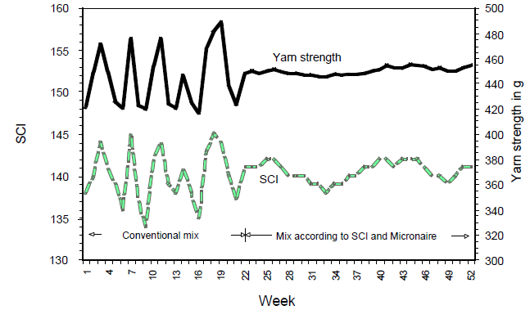

Figure 8 : Optimization of bale laydown and its results: Bale laydown optimization based on SCI and Micronaire starting in week 22, and according change in yarn strength: Yarn Strength, [Uster: HVI Application Handbook].
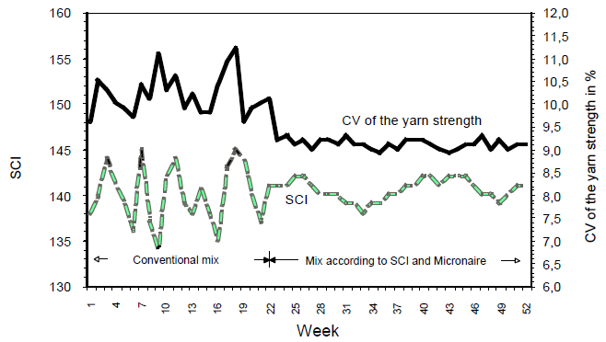

Figure 9: Optimization of bale laydown and its results: Bale laydown optimization based on SCI and Micronaire starting in week 22, and according change in yarn strength: Yarn strength CV% [Uster: HVI Application Handbook].

Use of test results: individual results vs mean results
All measurement data show measurement uncertainties. A quantification was already given in chapter 4.2 - . As measurement uncertainties cannot be avoided, we must learn how best to deal with these uncertainties.
For the following explanation we have to assume that the main problem of measurement results is a lack in precision (having a random variation), whereby avoiding systematic deviations in results as good as possible. All explanations are given for test results on bales.
A chance to deal with uncertain data is based on the given value distributions of several bales in a lot and their description. In the simplest case, a distribution can be described with a mean or average value (describing the position of a distribution) and a standard deviation (describing the width of the distribution). The central limit theorem illustrates that by using mean values instead of single values, the variation of results is reduced by the square root of the number of results from which the average is calculated. So, using averages of 25 results instead of single results, the variation is reduced to 1/5th. Using averages of 100 results, the variation is reduced to 1/10th. At the same time, the distribution of mean values is a normal distribution, even if the single results do not follow a normal distribution.

Figure 10: According to the central limit theorem, using a distribution of mean values instead of a distribution of single values will lead to a normal distribution with a lower variation [Uster: Uster Tester 6 Application Handbook].
For the case of selling/buying sales lots, it is important for the buyer that the demanded properties (e.g. strength) are fulfilled. This can be done based on the mean strength of all bales instead of the strength results of every single bale, avoiding the large uncertainty for the single test results. Certainly, it is additionally important to spinning mills as the purchasers that the sales lot doesn't include outlying bales. This cannot be assured with the mean strength, but it can by looking at the standard deviation of the strength results in addition. Especially in view of the fact that often not 100% of the bales are checked and tested, but only 10%, it is advisable that not single test results are used, but instead the statistical approach to using mean values and standard deviations. So contracts could specify minimum average strength results and maximum standard deviations instead of absolute limits for every bale.
Forming bale laydowns in the spinning mill is a different case. Here it is necessary to choose exactly those bales that in sum result in the right mean and standard deviation of the bale laydown. So it is advantageous to choose bales based on their single test results.
Finally, in cotton production, a suitable solution for homogenous seed cotton modules is to calculate the average of the test results of the single bales in the module (may it be 100% or a lower percentage of the bales). This average value can then be assigned to all bales in the module. Proceeding this way, the measurement uncertainty of the single measurements is avoided. So only in case of large variations within a module, single value may be assigned.

Micronaire
The Micronaire instrument measures the resistance offered by a plug of fibers of a known weight, compressed in a cylindrical chamber of fixed volume, to a metered airflow. The change in the rate of airflow, or pressure across the plug of fibers, was originally correlated with measurements of linear density, although it is now well understood the change is dependent upon the specific surface area of the specimen. This value represents the combination of the fiber’s linear density (fineness) and maturity; maturity being a measure of the fiber’s cell wall thickening.
Linear density is the appropriate form to measure cotton fineness because the cotton fiber cross-section is irregular in shape and hollow, which confounds two-dimensional measurements of fiber diameter that are applied to cylindrical, or at least consistently shaped, solid fibers such as wool and polyester.

Unit, range, significance in CSITC harmonization process
The original scale measured by the Micronaire instrument was calibrated with cottons that ranged in linear density from 2.3 μg/inch to 8.0 μg/inch. These representing the wider range of cotton species grown and traded last century. Current instruments limit the range to between 2.5 μg/inch and 6.0 or 7.0 μg/inch. The test method suffers from significant error at either end of the scale. An alternate scale exists for Pima-style (Gossypium barbadense) cotton. The name ‘micronaire’ is often notated mic, MIC or ‘X’, as per Lord’s work. The original calibration units of micrograms per inch (µg/inch) are hardly ever reported.
Significance at CSITC: Micronaire is a full parameter.
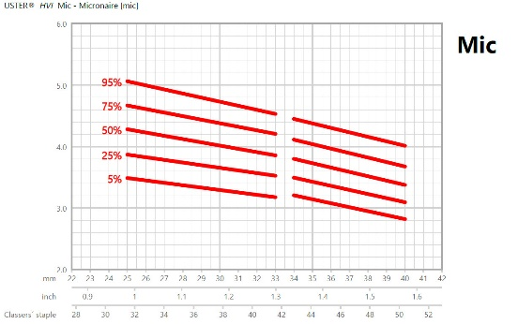

Figure 11 : Courtesy of Uster Technologies: USTER® STATISTICS for cotton (www.uster.com/statistics2018): Micronaire vs Upper Half Mean Length (UHML).
The original linear relationship observed between air flow and linear density used by the instrument was observed in the 1940s for a set of calibration samples all of similar maturity. Later studies with different samples showed results that varied significantly from the actual weight per unit inch determinations. Subsequent studies, particularly those by Lord^{2,} , showed the relationship between Micronaire and linear density was curvilinear and that changes in fiber maturity produced concomitant variations in Micronaire.
Figure 1 illustrates the above situation for a bale laydown from a large commercial, fine count yarn mill. Bales in this laydown originated from the USA, China, Australia and West Africa. Bale samples were tested for Micronaire (X), linear density (H) and maturity using Cottonscope. Maturity is defined in terms of maturity ratio (M or MR) as described by British Standard test method BS3085 or American Society for Testing and Materials (ASTM) International test method D1442.
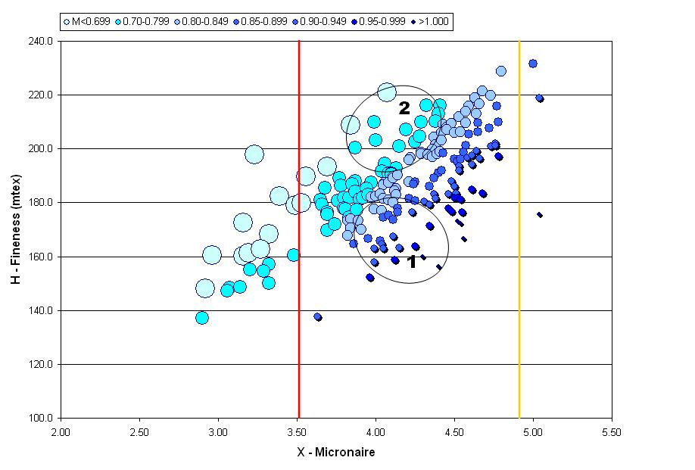

Figure 12: Micronaire (X) vs. fineness (H) (linear density in millitex (mg/km)) values for bales of cotton in a laydown prepared for fine count (Ne 50) ring spun yarn. Values are separated into maturity ratio (MR) values according to the legend.
Figure 11 reflects the sub-optimal practice of using Micronaire values to select the best cotton for the required end use. Because linear density and maturity results are not reported for classification in trade, bales with low values, i.e., <3.5, are considered questionable in terms of their maturity, whilst samples with high values, i.e., >4.9, are considered mature but coarse. For Micronaire values in the traded range (3.5 – 4.9), there is difficulty deducing whether the fibers are actually fine and mature or coarse and immature, without further testing. Figure 12 illustrates this situation using a single fiber cross-section.
The term ‘biological’ or standard fineness (Hs) is the ratio of fineness (H) to maturity (MR). In essence, this term relates the physical boundary (perimeter) of the fiber cross-section to the amount of secondary cell wall thickening that occurs during ripening. It is generally accepted that biological fineness is relatively constant for a given cultivar, although still normally distributed around a mean value. In terms of heritability, plant breeders have noted that fineness, and other fiber properties such as strength and length, are governed mainly by additive (multiple) gene effects that have only moderate heritability . Biological fineness will also vary with cropping and seasonal (environmental) effects.

Figure 13: Example of combination of maturity (MR, no unit) and of linear fineness (H, mtex) complex for a same Micronaire reading: for fibers with a micronaire value of 4.1, fibers could be fine and mature or immature and coarse. Standard fineness (Hs, in mtex) is the ratio of maturity to the linear fineness.

Existing measuring instruments for measuring micronaire
Micronaire instruments are manufactured by a number of companies according to the same airflow/pressure principle although specifications, e.g., chamber volume, specimen size, pressure control mechanisms and automation, vary. The original laboratory bench-top instrument of the late 1940s, which are still in use today, takes a well-blended and conditioned specimen of 50 grains (4 grams) in weight.
The Micronaire instrument was incorporated into high volume instrument (HVI) lines from the beginning of their development in the 1960s and has been changed to improve test time and precision. The HVI versions of the Micronaire instrument now take larger specimens (10 grams) that are usually unblended. The test can now be completed within 30 seconds, by e.g. widening the allowed range of the sample size.
A number of instruments have also been developed to separate the Micronaire value into its fineness (H in mtex) and maturity (M, no unit) components. These include the fineness and maturity tester (FMT), a double compression air flow test developed in the 1970s, the Advanced Fiber Information System (AFIS), developed in the 1980s and the Cottonscope, which emerged in the 2000s. Earlier versions of the AFIS and Cottonscope provided a calculated value of micronaire (X) using Lord’s conversion equation; see Equation 1. The table below lists current instruments available to measure micronaire and its maturity and linear density properties.
MH = 3.86X² + 18.16X + 13.0 (Equation 1).

Several new high volume testing instrument lines that include different double compression test instruments, in order to allow the determination of fineness and maturity during high volume testing, have been developed in the last five to 10 years. These include the Premier Evolvic ART 2 and ART 3 systems and more recently the Mesdan Contest-S.

Table 6: List of instruments measuring micronaire.
Instrument | Machine type | Additional linked measured characteristic(s)*
Stand-alone airflow instrument | Micronaire value from direct measurement of airflow (specific surface area on weighed plug of fibers) | No
Airflow instrument integrated into high volume instrument line | Micronaire value from direct measurement of airflow (specific surface area on weighed plug of fibers) | No
Stand-alone (or integrated) double compression airflow instruments | Differential airflow from double compression readings are related to (micronaire), maturity and fineness values | Maturity and fineness (linear density)
Individual fiber analysis instruments | Light scatter (AFIS) on weighed specimen from individualized fibers, neps and trash particles  Image analysis (Cottonscope) on weighed specimen of individualized fiber snippets | (Micronaire), maturity, (neps), linear density, fiber ribbon width and fiber property distributions
Image analysis on cross sections | Research related test methods, mainly for reference purposes | Maturity and fineness as defined on the cross section
*Depending of the model used.

Description of any relation between ‘manual and visual grading’ and ‘instrument classing’ evaluation results
Experienced classers should be able to discern the adverse effects of low micronaire, immature cotton. In less homogenized samples like those from roller-ginned, cotton groups of dead or immature fiber can be observed. A higher content of immature fibers can be connected with a lower grade of cotton.
Low micronaire or immature fiber can markedly affect the appearance of raw cotton. Notably the lack of cell wall development in immature cotton can result in cotton fibers feeling softer and in an overall shorter staple length.
The lack of rigidity also means that immature cotton has a greater tendency to form neps (small entanglements). Immature cotton processed through the same harvest and ginning systems will have markedly more neps than more mature fiber.
Immature cotton also has poor luster (dulled appearance) because of the less circular nature of the fiber’s cross-sections, which result in diffuse rather than specular reflectance of light. High micronaire fiber is typically brighter and usually cleaner of plant trash and leaf compared to low micronaire cotton of the same origin.

Evaluation results present in ‘manual and visual grading’ but missing in ‘instrument classing’ evaluation results
At the seed cotton stage, before ginning and mixing the harvested seed-cotton, the amount of immature or dead fibers can often be estimated visually. Opposite to instrumental testing, there are seed cotton standards available in many countries with hand-picked cotton. The seed-cotton is sorted visually then according to the main obvious aspects trash content, and color, but in many cases also according to the amount of immature or dead fibers. The lower the standards the higher is the amount of immature fibers in the cotton and the tendency to lower micronaire values in the ginned cotton.
In roller-ginned cotton, one can often see the above mentioned agglomerations of immature fibers in the ginned cotton. Therefore, a micronaire test can be influenced without the necessary care during testing and repeating testing of the same roller-ginned sample

Use of Micronaire results for cotton production
For any given cotton variety, a high micronaire reading, compared to a typical value, indicates that good production conditions were present during the maturation of the cotton fruit (boll). Under optimal production conditions, i.e., optimal water, sunlight and nutrients, and low pest pressure, a given variety will produce mature fibers that may result in Micronaire readings on the upper side of the Micronaire distribution for that variety. Changes in production conditions alone, and in interactions, e.g., heat and water availability, play a role in affecting the final Micronaire reading.
The measurement, or prediction, of Micronaire in the field would provide growers with a measure against which they could manipulate growing conditions, e.g., defoliation and/or harvest timing, to ‘optimize’ the Micronaire (maturity) of a crop. With the increase in automation and management of the crop on many farms, farmers and scientists are looking at predicted or measured field values to optimize the yield and quality of their crop. Many studies have reported significant relationships between temperature (daily average and minimum temperatures) and Micronaire. With the current rapid progression in precision agriculture, i.e., the use of sensors and instruments in the field to provide rapid measurement of crop development, these relationships are now being used to develop prediction models for managing the Micronaire of a crop.

Use of Micronaire results in ginning
Measurements, or prediction, of Micronaire in the field (as per Section 5.5 - ) could be applied to manage ginning processes, although in practice there is usually no assessment of seed-cotton fiber properties, other than moisture and plant trash levels, before ginning. That said, there is currently research underway to determine the efficacy of blending seed-cotton (modules) at ginning, on the basis of crop maturity and leaf content (at harvest). The outcomes of this research would have benefits both to smaller gins that service many smaller growers and the larger, automated gins that service large farms.
It is also noted that any immature crop, i.e., a crop with a high percentage of immature fruit (or bolls) ought to be considered carefully before any ginning or mechanical processing. It is well known that immature fiber leads to increased nep and trash content as well as fiber breakage during ginning, particularly during lint cleaning.
Finally, finer (lower) Micronaire cotton fibers tend to form neps more easily than coarser fibers, since the former are more easily bent, buckled and entangled during mechanical manipulation due to their relatively low longitudinal rigidity. Immature fibers have low rigidities (and high buckling coefficients) and are thus more easily entangled into neps during mechanical handling and manipulation, particularly during lint cleaning.

Use of Micronaire results for trading
As discussed, the use of Micronaire to value cotton is made ambiguous because unless additional measurements are made to determine the maturity and fineness of the fiber, the exact nature of the purchase, in terms of these properties, which are important in spinning and fabric manufacture, remains unknown. These aspects are illustrated in Figure 11. The plot shows the G5 range contains cottons of very different processing quality in terms of fineness and maturity. Two circles within the range highlight the shortcomings of the Micronaire measurement. The bales highlighted by each circle represent the same narrow Micronaire range; 4.0 – 4.2, however the fine and mature cotton bales in circle 1 have very different processing, yarn and fabric properties to the coarser, immature cotton highlighted in circle 2. The fine, mature cotton will produce a more even, stronger yarn and fabric that has better luster and dye uptake than the coarser, immature cotton.
Micronaire has remained the market’s method of choice to assess fiber fineness (and maturity) largely because of its easy measurement, speed, reliability and the market’s entrenched acceptance of its values. The majority of (Upland) cotton crops worldwide are traded within the Micronaire range of 3.5 to 4.9, with significant discounts applied to cotton outside these values. For example, discounts are applied to US loan cotton on the basis of Micronaire values outside an ‘optimum’ range; wherein the cotton is not judged too coarse nor immature but ‘just right’. Similar values are applied to other export growths. Note the ‘optimum’ range is wide and that only (small) premiums are paid for cotton with a narrower Micronaire range, e.g., G5B termed cotton with a range between 3.7 and 4.2. The exception to this classification is the range of values measured for Pima-type (G. barbadense) cotton, which is measured on a different Micronaire scale.
Micronaire is one of the two key instrumental guaranties for international trading. According to the international ICA trading rules it is in principle a minimum guaranty without application of a testing tolerance. In international trading based on the Rules of the International Cotton Association usually a minimum guaranty and more often a range for the Micronaire values is agreed. Unless otherwise agreed between buyer and seller, no tolerances or control limits for testing are applied. The discounts for deviations from the contractual guaranty either below or above an agreed range or below a fixed value are expressed in percentages of the contract price.
The Universal Cotton Standards Agreement as well as national regulations and internationally agreed ICCTM/CSITC recommendations are the basis for instrumental testing practices and standards laid down in trading rules for dispute resolution.

Use of Micronaire results for spinning mills / textile processing
Despite the known ambiguity of the Micronaire measurement, the value is still valuable in the spinning mill as a predictor; of a fiber’s spinning limit, i.e., the number of fibers in the yarn cross-section required to resist the tension applied during spinning; of the yarn’s evenness and tenacity; and of the dye uptake by the resulting yarn or fabric. It is noted relationships with the fiber properties of the resulting yarn and fabric products are better if separate fineness and maturity results are used. Nevertheless it is noted that:
- Micronaire is a good predictor of dyeing ability and dyed fabric appearance. Higher micronaire fiber will take up more dyestuff (color) and because the fibers tend to be more circular, the dyed fabric is typically more even and lustrous in appearance. Figure 3 shows yarn spun from the same genetic material, and therefore of similar ‘biological’ fineness, but harvested at different dates to give a wide range of maturity (MR) values. The micronaire values reflect the different maturity of the samples. The yarns were knitted in bands into the same fabric, which was then dyed.
- Micronaire can be used to estimate the spinning limit of the cotton fiber for a given spinning system, e.g., ring, rotor (open end) or air-jet spinning. Lower Micronaire fibers, to an extent, are favored because the number of fibers in the yarn cross section can be increased, providing greater yarn stability, strength and evenness. The mitigating fact for low-Micronaire cotton is that it must also be reasonably mature or not too low in Micronaire otherwise there will be an increase in yarn neps. Herein lies the ambiguity of the Micronaire value.
- In order to provide consistency of quality through a spinning mill, the variation in Micronaire (maturity and fineness) values between bales in a laydown, and between laydowns on a continuous time scale, must be managed. Paragraph 4.4 - describes bale management regimes that can be used to avoid inconsistencies in yarn and fabric quality arising from changes and variations in Micronaire and other fiber properties.
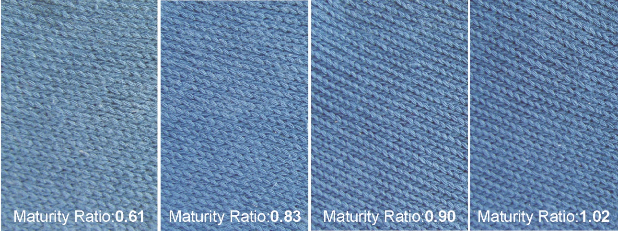
Figure 3: Fabric samples with common genetic backgrounds, harvested at different dates and processed into a single knitted fabric that was then dyed. The photos show the improvement in fabric in terms of color depth, evenness and appearance as maturity (Micronaire) increases.

Length measurement
The length of a fiber is the distance between its both ends while it is maintained aligned under a standard tension. For trade, many fibers are tested at a same time using a beard of randomly selected and parallel fibers in a comb, with each fiber clamped at a random position of its length (and not at its end).. The length of the fibers extending out from one side of this comb are scanned and results are displayed in a specific chart called Fibrogram (Figure 13); this corresponds to the clamp line of rollers in the spinning process (Figure 16). Cotton fibers have a high variation in length and having very short fibers and long fibers together within the same fiber tuft.
Various techniques have existed to measure representative cotton fiber length (end aligned method where fibers are reordered end aligned, single fibers measurements, Staple diagrams, …). Evaluations can be done by weight or by number. For evaluation of fiber damage the by-number distribution are more sensitive.
By convention, in the Fibrogram (a by-weight distribution), length results have been defined as the lengths corresponding to given percentiles in that beard and are computed from that Fibrogram. For trading purposes, ICAC-CSITC Task Force solely recognizes the ‘mean length’ type of interpretation of the Fibrogram; results are then 1) Upper Half Mean Length (UHML), Mean Length (ML) and the Uniformity Index (UI) (UI= ML/UHML*100) . The Upper Half Mean Length corresponds to the classer’s staple.
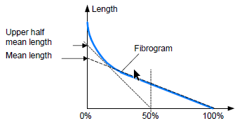

Figure 14: Fibrogram and related information.
Fiber length is an important characteristic that has impacts on the type of final product and its characteristics, on machine settings (distance between rollers, twist, etc.) and also on yarn properties such as yarn evenness and yarn hairiness.
Fiber length in a bale depends on many production (variety, sowing date, climate and cropping conditions) and ginning conditions (moisture content, trash content in relation to the number of cleaners, maintenance of ginning parts…). Indeed, each time each fiber gets in contact to any machine part partly increases the probability to break it in relation to its ‘native and intrinsic’ properties, and then shorten its length. Overall, the whole fiber length distribution in a sample – also displayed as a Fibrogram - is affected, and corresponding UHML, ML and UI results are changed.

Unit, range, significance in CSITC harmonization process
Upper Half Mean Length (UHML) corresponds to the average length of the upper half of the fiber beard. Its usual (largest) range is between 24 to 38 mm or 1.0 to 1.5 inch (Figure 14).
Mean Length corresponds to the mean length of all fibers present in the beard.
Uniformity Index corresponds to the ratio ML/UHML*100, and is expressed in percent. Its usual range is between 75 to 90%, strongly depending on the UHML of the sample. (Figure 14).
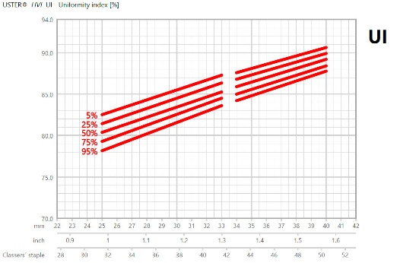

Figure 15: Uniformity Index vs Upper Half Mean Length (UHML) [Uster].
The short fiber index (SFI) may also be given as the amount of fibers of less than 0.5 inch (<12.7mm) and are either calculated based on this span length distribution or are based on algorithms based on data of end aligned methods in comparison to the span length measurement. It is typically compared to the short fiber content by weight.
Short Fiber Index (SFI) has a usual range between 7 and 25%, again strongly depending on the UHML of the sample (Figure 15).
Significance at CSITC: UHML and UI are full parameters (ML is then being indirectly included due to its relation to UHML and UI) while SFI is, due to its high inter-laboratory variation, an optional parameter at CSITC.
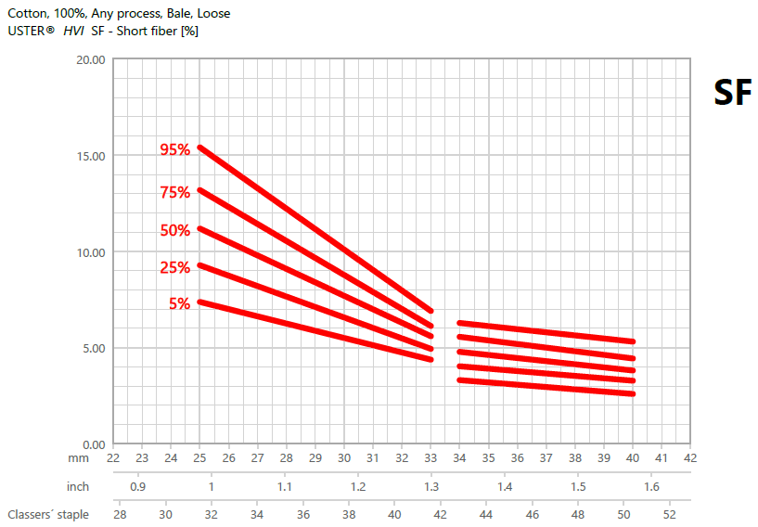

Figure 16: Short fiber index vs Upper Half Mean Length (UHML) [Uster].

Existing measuring instruments for measuring length parameters

Table 7: List of instruments measuring length.
Instrument | Machine type | Additional linked measured characteristic(s)*
Stand alone instrument | Spinlab, Textechno Fibrotest | Span length 50% and Span length 2.5%, Uniformity Ratio, UQL, SFC, SFI
Modules in high volume testers | Uster, Premier, MAG Solvics; Mesdan Contest-F, Textechno Fibrotest | Length, Strength, Elongation, Trash, Micronaire, Stickiness, Neps
*Depending of the model used.

Description of any relation between ‘manual and visual grading’ and ‘instrument classing’ evaluation results
Basis for the applied scale for manual accessed fiber length is a certain technique for the forming of a fiber beard as well as standards of physical cotton, which the USDA provided to the international trade in the past. Physical standards are still used by ICA Bremen and the Bremer Baumwollboerse as reference for the manual measurement of length.
Manual classing of fiber length is typically given by the classer in 1/32“ of an inch based on practical experience. Besides the physical fiber length also the preparation and ginning of the fiber sample affects the grading. This is taken into account with the different calibration ranges for Upland and Pima cottons, as Upland cotton varieties typically are saw ginned, whereas Pima cotton varieties are more generally roller ginned, and “seem” to be slightly shorter on HVI compared to manual classing. Usually there is a good relation between a classer’s staple length and the HVI UHML as well as the AFIS UQL. Reason for deviations in the readings can the different preparing of the fiber beard for measurement.
The fiber length distribution within a sample and the fiber structure may have an influence on the evaluation of the manually ascertained staple length. Often the results of manual classing of length are more consistent and with less fluctuation to the upper and lower end compared to HVI results, although the average result is similar.
Manual staple pulling gives just a basic indication for other length related parameters especially in comparison to a different sample from the same variety and growing area. Due to the nature of the fiber development, staple pulling can provide a first impression on a deviation in strength or fineness in comparison with other samples.

Evaluation results present in ‘manual and visual grading’ but missing in ‘instrument classing’ evaluation results
The effect of the preparation – i.e. if the cottons are saw or roller ginned are not considered in instrument classing, but will have an effect in further processing during spinning. Twisted ginned fibers need gentler handling in later processing steps unless fiber breakage would increase.
The manual classing of length provides one fixed value only, sometimes with added impression in comparison to the next higher standard length like ‘irregular‘ or ‚full‘, which are added to the fiber length result based on the appearance of the ends of the produced fiber beard. To some extend it reflects the range of length measurements for a staple length provided by the HVI.
Testing devices provide more detailed values, which have to be fixed by defined frames by agreement, as well as other length related fiber characteristics.

Use of Length results for cotton production
For the production side, fiber length in a bale depends on many production conditions such as variety, sowing date, climate and cropping conditions, and their interactions. It should be added that any fiber length information only is available after a ginning process (by hand, by roller or by saw) that also affect fiber length. Given a harmonized and stable ginning process along time, any length information will bring insight about crop management in general terms.

Use of Length results in ginning
Fiber length will determine whether the seed cotton is saw or roller ginned and, at the same time, ginning conditions (moisture content at each step, trash content in relation to the number of cleaners, maintenance of ginning parts…) affect fiber length distribution. Saw gins are generally used to process Upland-type cottons of short to medium staple length (˂1 inch to 1 7/32 inch) and is consequently the most prevalent type of gin in the world. All Extra Long Staple cottons (≥1 3/8 inch) are ginned on roller gins, and it is estimated that currently 15 to 20% of Long Staple Upland and medium staple cottons (≥11/16 inch) are ginned on roller gins.
In the gin, fiber length can be preserved, and short fiber content reduced, by reducing the number of lint cleaner passages (depending on quality of seed cotton) and ensuring fiber moisture at the gin and lint cleaner is closer to 7% than 5%; however, fiber moisture at either point should not exceed 7%.

Use of Length results for trading
Length is one of the three key guaranties in international cotton contracts, which can be assessed by instrumental testing as well as manual classing. Common for the international trade with manual classing results length values are expressed in 32nds of inch. Other length units are in use under consideration of different procedures in the cotton production.
Fiber length for instruments are usually given in mm or in decimals of inch, translated with25.4 mm per inch. Only in the US, the instrument length might be given in 32nds of an inch. This is specifically for long cottons not identical with the mathematically defined decimals of an inch. The instrument test instruments however give often the value in decimals; the CSITC Testing Guide provides the best information on how to present length results. The majority of the traded lengths is in the medium to upper medium staple range, which is therefore an area of high competition between cotton producing countries.
In ICA arbitration, the results of instrumental testing can be used by agreement. In case of no agreement manual examination is the default position. According to common understanding and the ICA rules, length is a minimum guaranty without application of a tolerance. The discounts for deviations from the contractual guaranty are fixed for various growths by national cotton organizations and the ICA for the international trading. Usually the discounts are expressed as a monetary value based on traded market differences reflecting the value of the cotton for buyers and sellers.
The Universal Cotton Standards Agreement as well as national regulations and internationally agreed ICCTM/CSITC recommendations are the basis for instrumental testing practices and standards laid down in trading rules for dispute resolution.

Use of Length results for spinning mills / textile processing
Fiber length is, jointly with fineness, the most important parameter for estimating the maximum achievable yarn count. Based on the fiber length in the process, the roller distances are derived and set (Figure 16). If the roller distance is too wide the fibers are “floating” and will cause thick places or a high unevenness. If the roller distance is too short, it might cause fibers to break with an increase in short fiber content will increase.

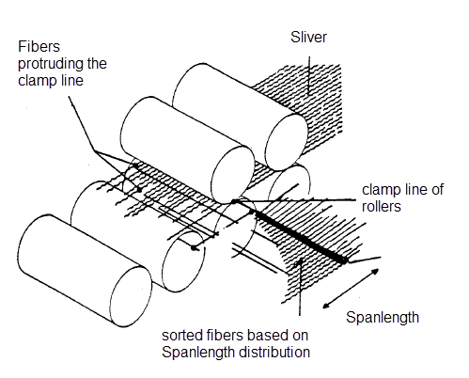

Figure 17: Fiber length distribution in a drafting zone.

Strength measurement
Fiber strength is seen as an important parameter, as it has direct impact on the later yarn strength, as it contributes about 50% of the final yarn strength. In addition, the twist factor will add to the binding of the fibers into the yarn structure and a higher twist will also result in a stronger yarn.
Depending on the calibration cottons two levels are common. The most used level is today the HVI-HVI calibrations (supplied by USDA, USA).
Besides the measurement of single fiber, in cotton classing the fibers are typically grabbed into a clamp, which is then placed into the unit for the tensile testing. So here the fibers are tested in bundle form.
As the fiber strength is moisture dependent it is important to perform especially this test under fixed ambient conditions, as cotton fiber strength increases with a higher air humidity (moisture content in the fiber).

Unit, range, significance in CSITC harmonization process
Strength, tensile strength or tenacity, in SITC instruments usually referred as strength: g/tex, gf/tex, cN/tex
Short name or abbreviation: STR,
Usual range is between 15 - 40 cN/tex

Elongation in %
Short name or abbreviation: ELONG, E%
Usual range is between 5-9%
Significance at CSITC Strength is a full parameter, and elongation is, due to its high inter-laboratory variation, and the given difficulties in calibration, currently not at CSITC.
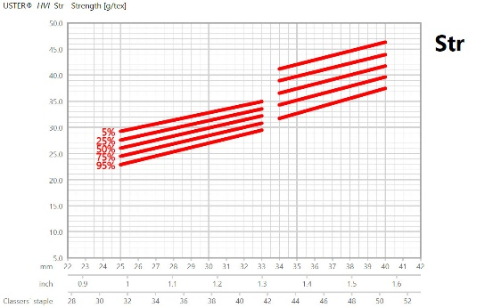

Figure 18: Strength vs Upper Half Mean Length (UHML) [Uster].
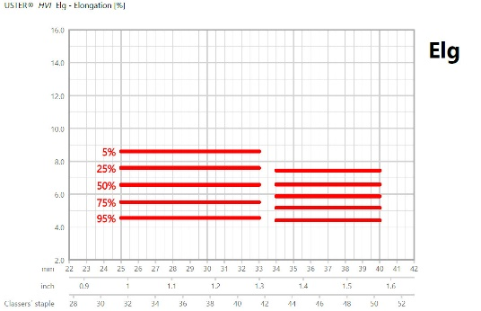

Figure 19: Elongation vs Upper Half Mean Length (UHML) [Uster].

Existing measuring instruments for measuring strength

Table 8: List of instruments measuring strength.
Instrument | Machine type | Additional linked measured characteristic(s)*
Single fiber testing | Textechno (Favigraph and Favimat), Lenzing (Vibrojet), Uster (Mantis) | Strength, Tenacity, Elongation
Stand alone instrument | Textechno (Fibrotest) | Strength, Tenacity, Elongation
Modules in high volume testers | Uster, Premier, MAG Solvics Pvt. Ltd.; Contest-F | Length, Tenacity, Elongation  Trash, Micronaire
*Depending of the model used.

Table 9: Interpretation or classification of strength results.
Tenacity in cN/tex  [Universal and CSITC for Upland cottons] | Description
< 25 | Very weak
26 - 31 | Weak
32 - 36 | Medium
37 - 40 | Strong
> 40 | Very strong

Table 10: Interpretation or classification of elongation results.
Elongation (%) | Description
< 5 | Very low
5.0 – 5.8 | Low
5.9 – 6.7 | Medium
6.8 – 7.6 | High
> 7.7 | Very high

Description of any relation between ‘manual and visual grading’ and ‘instrument classing’ evaluation results
Beyond impressions explained hereafter, a certain statement about the strength is not possible based on manual classing. There is no trustworthy connection to instrumental testing results.
However, by pulling the fibers to form a fiber beard, experienced classers might give an indication about weaker or stronger cotton fibers in a sample compared to a different sample of another growth of especially or of the same growth. Weaker fibers may cause more breakages during the pulling. Mature, stronger fibers feel more resistant. In connection with the regular feedback by instrumental tests and perceived quality outturns of previous seasons of a growth a rough impression can indicate a deviation from a usual outcome.

Evaluation results present in ‘manual and visual grading’ but missing in ‘instrument classing’ evaluation results
Opposite to instrumental testing, manual classing cannot provide an accurate and reliable result for strength.

Use of Strength results for cotton production
Fiber strength is depending on other fiber properties such as maturity, fineness measuring the impact of production conditions onto fiber development when on the cotton plant.

Use of Strength results in ginning
Excessive seed-cotton drying and an excessive use of lint cleaners can result in higher grades, but can cause reductions in fiber length (by as much as 5%), a decrease in uniformity, in fiber strength and in elongation with an increase in short fiber content. Indeed, gins are often encouraged to over-clean cotton, to achieve a higher grade and a higher price being paid for the cotton lint and therefore a better return for the grower. Unfortunately, this practice is often to the detriment of fiber quality, as it can adversely affect fiber length and uniformity, strength and elongation, neps and seed coat levels and size, as well as short fiber levels, all of which will affect the processing, performance and downstream value of the cotton. Ginning represents, in essence, the achievement of a compromise between fiber trash content and fiber quality/integrity, with each mechanical or pneumatic device used to clean and gin the cotton leading to a deterioration in fiber quality.
In general, the effect of ginning on the fiber strength is not that high. The seed variety and growing conditions have a higher influence. Saw gins may damage fibers more than roller gins. The higher amount of damaged fibers in a fiber bundle used for strength measurement can somewhat lower the strength test result.

Use of Strength results for trading
Strength is the second of the two key instrumental guaranties for international trading. The acceptance for trading is facilitated by quite reliable testing results and the often well-known and typical range of test results within a cotton of a certain season, planting area and quality standard.
According to the international ICA trading rules, a strength value in a contractual quality description is a minimum guaranty without application of a testing tolerance. A control limit has to be agreed separately.
Usually the discounts for deviations from the contractual guaranty below an agreed value are expressed in percentages of the contract price.
The Universal Cotton Standards Agreement as well as national regulations and internationally agreed ICCTM/CSITC recommendations are the basis for instrumental testing practices and standards laid down in trading rules for dispute resolution.

Use of Strength results for spinning mills / textile processing
The tensile test of cotton fibers is commonly tested on a bundle of fibers as this is faster than the single fiber strength test. Spinning mills use Strength together with fiber length, length uniformity and fiber fineness (Micronaire) as quality parameters as they affect yarn strength. This is not only relevant for the yarn, but also later for fabric strength. For instance, fabrics that are resin-treated (for iron-free finishing) lose fabric strength, and thus for this application extra-long staple cottons with high tenacity values are the preferred choice as compensation.
Table 11 shows the priorities and significant parameters for the different spinning systems.

Table 11 : Priorities and significant parameters for the different spinning systems.
Ring spun yarns | OE rotor yarns | Air jet yarns
Length | Strength | Strength
Length uniformity | Fineness | Length
Strength | Cleanness | Cleanness
Maturity | Length | Fineness
Fineness | Length uniformity | Length uniformity
Elongation | Elongation | Elongatin
Cleanness | Maturity | Maturity
Color | Color | Color

Color measurement
Color is one of the most important properties of cotton. It can be affected by many factors: variety, cultivation conditions such as: soil, rainfalls, freezes, insects and fungi, contact with soil, grass, etc., as well as by the condition of ginning, transportation and storage: moisture and temperature, bale wrapping, etc.
Traditionally, cotton color was assessed by cotton classers in an organoleptic - visual way. A specially trained expert classifies cotton sample by the visual comparison with a set of physical standards under standard illumination and/or according to description of color grade. Visual assessments are performed in rooms with grey walls with samples placed on a black desk illuminated by light of illuminance 1200 lx.
In the 1930’s the USDA started developing the instrumental color measurement. Two parameters have been introduced into the cotton grade classification: the grayness - the degree of the reflectance (Rd) and the yellowness (+b). The degree of reflectance (Rd) indicates how bright or dull a sample is and the yellowness (+b) indicates the degree of color pigmentation. The cotton color grade is determined instrumentally in a two-filter colorimeter. This objective method was developed by Nickerson and Hunter in the early 1940’s to check the USDA cotton grade standards. The Hunter scales used in the Nickerson Hunter Cotton Colorimeter indicate vertically the percentage reflectance (Rd), which is a measure of the lightness of a sample, and in a horizontal direction - the yellowness (+b) (Figure 19). The color code is determined by locating the point at which the (Rd) and the (+b) values intersect on the Nickerson-Hunter cotton colorimeter diagram for Upland cotton. Other classifications are also possible.
In the 1970’s the colorimeter technology has been integrated into the HVI. The degree of reflectance (Rd) determined by the HVI shows the brightness of the sample. It corresponds to the reflectance (Rd) represented in the Nickerson-Hunter color chart. The yellowness (+b) according to the HVI is determined by using a yellow filter. It depicts the degree of cotton pigmentation. The yellowness (+b) from the HVI corresponds to the (+b) value represented in the Nickerson-Hunter color chart. The yellowness (+b) is used in the conjunction with the reflectance (Rd) value to determine the instrument-measured color grade (CG) of cotton.
Normally, color of different objects has three dimensions which can be determined by spectrophotometer. It provides the color data in CIE (Commission Internationale de l'Eclairage) L*a*b* color space. It is the most popular, standardized color space. By means of the spectrophotometer the following color coordinates can be determined:
- L* – lightness, and chromaticity coordinates:
- a* – green/red,
- b* – blue/yellow,
- C* – chroma; it is attribute of color used to indicate the degree of departure of the color from a gray of the same lightness [18],
- h – hue angle; it is attribute of visual perception according to which an area appears to be similar to one of the colors, red, green, yellow and blue, or to a combination of adjacent pairs of these colors considered in a closed ring.
Some instruments applied in cotton color measurements provide the L, a* and b* color coordinates.

Figure 20: The Nickerson-Hunter cotton colorimeter diagram for Upland cotton; Source: http://www.cottoninc.com/fiber/quality/us-fiber-chart/hvi-color-chart/.

Unit, range, significance in CSITC harmonization process
- Color grade – CG; 25 Color Grades and 5 categories of below grade color (Table 13),
- Yellowness – (+b); range according to fig. 1, no unit
- Reflectance – (Rd); range according to fig. 1, expressed in percent
- Lightness – L*, no unit
- Chromaticity coordinate a* (green/red) – a*, no unit,
- Chromaticity coordinate b* (blue/yellow) – b*, no unit.
Significance at CSITC: Reflectance and yellowness are full parameters.
For converting Rd and +b to the Color Grade CG, at table is available that gives the CG for any tenth of the Rd unit and any tenth of the +b unit. As the calculation is not linear, it is not possible to apply usual calculations like Average or Standard Deviation on CG. Instead, the calculations should be done for the Rd and +b values.
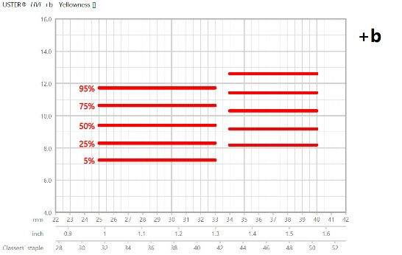

Figure 21: Yellowness vs Upper Half Mean Length (UHML) [Uster].
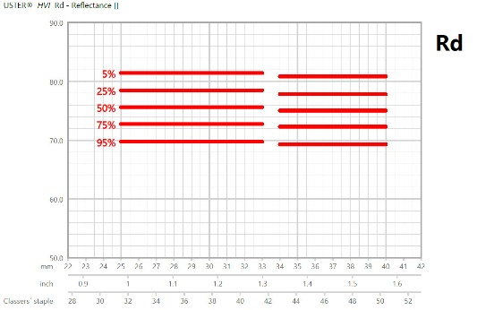

Figure 22: Reflectance vs Upper Half Mean Length (UHML) [Uster].

Existing measuring instruments for measuring color

Table 12: List of instruments measuring color parameters.
Instrument | Machine type | Additional linked measured characteristic(s)*
Organoleptic/subjective way | Specially trained cotton classers - visual comparison with physical standards | Leaf Grade, staple length, preparation
Modules in high volume testers | Uster, Premier, MAG Solvics Pvt. Ltd. – direct measurement of: (+b) and (Rd), next calculation of CG (Color Grade) | Length, strength, trash, micronaire
Modules in high volume testers | Fiber Classifying System, Textechno – measurement of (Rd) and (+b), CG, L*, a*, b* | Micronaire, length, strength, neps and trash, Leaf Grade
Modules in high volume testers | Contest-F –measurement of (Rd), (+b), calculation CG for digital image of cotton sample | Trash, neps, length, stickiness, micronaire, maturity
Stand-alone instruments | Spectrophotometer direct measurement of L*, a*, b*  Digi Eye, measurement of L*, a*, b* for digital image of cotton sample | C* – chroma; h – hue angle
*Depending of the model used.

Description of any relation between ‘manual and visual grading’ and ‘instrument classing’ evaluation results
According to the literature review an agreement between the visual and instrument grading is ca. 70%. For cotton not originated in the U.S the compatibility between the classer and HVI grading is lower, ca. 50 – 75%.
Usually there is a sufficient and at least understandable relation between the readings of instrumental tests and manual classing as long as the quality evaluation is connected to the Universal Standards for American Cotton. A bad preparation, distinct and big spots, gin faults or dirty samples influences the measurement by instruments more than by visual classing.
Due to the increasing frames of the grades outside the normal descriptions like Color grades 83 to 85, manual classers may give a more detailed grading of the cotton than provided by the HVI.
Manual classing of color is related to an applicable set of standards of an origin. There are different standards in cotton producing countries which are used for the grading of color. In terms of color determination, these standards usually combine the reflectance, yellowness and brightness of cotton together with the preparation, which might influence the color reading.
For instrumental testing on side of the spinning mills, the measured values for reflectance and yellowness are converted into color grades of the Universal Standards. In this regard a comparison of the standards applicable for different origins with instrumental color readings is often difficult, although a correlation is possible based on a comparison with the physical Universal standards boxes and experience.

Evaluation results present in ‘manual and visual grading’ but missing in ‘instrument classing’ evaluation results
Preparation – assessed visually – expresses a general appearance of fibers and fiber tufts. It refers to the degree of roughness or smoothness of the ginned lint cotton.
The physical standard boxes of some countries cover a slight range in color, where others present just one color outturn. In any case, the lowest color determines the acceptable outturn for this specific standard. Every outturn represents degrees of the next lower standard.
The commercially used testing instruments do not differentiate very well between hard spots and overall yellowness. The influence of the preparation of the sample on the color measurement can hardly be evaluated.
Due to the kind of instrumental color measurement, cotton with a uniform yellow touch due to planted varieties and production practices can be more devalued than economically appropriate.
For cotton outside the normal range and at the lower end of the quality range, the instrumental grading might give an insufficient description of the quality of cotton.

Use of Color results for cotton production
Improvement of color can be achieved by a harvesting the crop as soon as possible. When a boll first opens, the lint is white and clean due to the highly reflective nature of cellulose and the lack of microbial degradation. If the fibers are wetted due to rain, it is advised to wait for the crop to dry and bleach from sun and wind, prior to harvesting. However, when lint is exposed to moisture for a long time the lint can become grey and dull due to grow of fungi on the lint surface.

Use of Color results in ginning
Lint cleaners remove leaf particles, grass, motes, stems, bark, seeds, fine trash, sand and dust, and can improve the grade of cotton, by removing the foreign matter as well as by blending light spotted.

Use of Color results for trading
Color as part of the grade description is one of the key guaranties in international cotton contracts, which can be assessed by instrumental testing as well as manual classing.
Color is a basic criterion, which decides on the quality classification of cotton raw materials according to the Universal Cotton Standards globally accepted and routinely used in many countries as the standard for U.S. and non-U.S. grown cottons. The Color Grade is determined according to the official standards for American Upland cotton, and it is a combination of (Rd) and (+b) according to the HVI results.
A three-digit color code is determined by locating the point at which the (Rd) and (+b) values intersect on the color chart (Figure 19).
Major color differences occur between the five groups (Table 13):
- White,
- Light spotted - LtSp,
- Spotted - Sp, a
- Tinged - Tg,
- Yellow’ stained - YS
In each class, the reflectance or whiteness of the fiber is assessed across another eight levels from Good Middling (GM) to Below Grade (BG) (Table 13).
There are currently 25 official physical color grades for Upland cotton and five grades for below grade color. Fifteen of these grades are represented in physical form by boxes of cotton representing the full range of each standard (Figure 22), while the remaining 10 grades and five below grade categories are descriptions based on the physical color grade standards.

Table 13: Color grades of Upland cotton (* - Physical standards for color grade # - Physical standards for leaf grade).
 | White | Light spotted | Spotted | Tinged | Yellow stained
Good Middling (GM) | 11* | 12 | 13 | - | -
Strict Middling (SM) | 21*# | 22 | 23* | 24 | 25
Middling (M) | 31*# | 32 | 33* | 34* | 35
Strict Low Middling (SLM) | 41*# | 42 | 43* | 44* | -
Low Middling (LM) | 51*# | 52 | 53* | 54* | -
Strict Good Ordinery (SGO) | 61*# | 62 | 63* | - | -
Good Ordinery (GO) | 71*# | - | - | - | -
Below Grade (BG) | 81 | 82 | 83 | 84 | 85
Color Grade is reported as a three-digit number, such as 41-1, which is the current base grade. The lower the number, the better; for example, a 31-1 is superior to the base grade of 41-4. For more information, see the CSITC Testing Guideline.
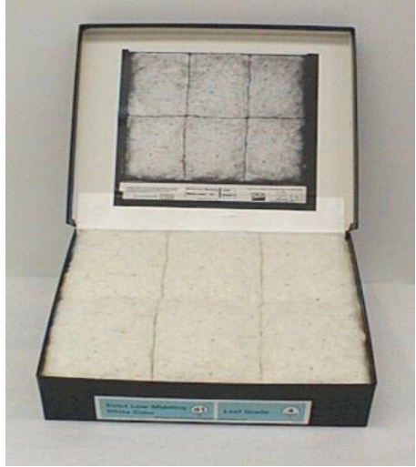

Figure 23: An example of physical standards for Color Grade .
There are other standard systems in different cotton producing countries which play a role for trading cotton within a country or in the sourcing process for export. These standards reflect the used varieties and production practices as well as environmental influences. To evaluate the cotton to these standard systems in comparison to HVI measurements experience and a data base is necessary to create a contract which low quality risk.
The fact that parts of the HVI measurements are extensively used by spinning mills to compare different qualities and growths has incidences on trading practice and on the content of contractual quality guaranties. Under ICA rules, there are no separate value differences for color readings. Discounts for color are incorporated into the grade discounts expressed as a monetary value based on traded market differences for different qualities.

Use of Color results for spinning mills / textile processing
Reduced color negatively affects spinning efficiencies and diminishes the dyeing properties of fibers. Due to this fact the deterioration of color indicates lower processing efficiency and at the same time - lower market value of cotton.
Laydown preparation should take into consideration the color consistence of spinning blend (also see 10.1 - ). In other cases, there is a risk of color shades in yarn. To ensure uniformity in the end-products (yarns and fabrics), cotton must be blended from several bales to make length and color of cotton blend as uniform as possible. Color worsening affects also ability of fibers, and in the same time the textile products made of these fibers, to absorb and hold dyes and finishes.

Trash count and area
Cotton trash, or trash for short, is defined as the non-lint material found in a cotton sample. Trash is measured in terms of the particle count and percent area of non-lint particles found on the surface of a pressed cotton sample. More specifically, particle count is defined as the number of particles measured on a 58 cm² pressed cotton surface. Percent area is measured simultaneously with particle count and is a measure of the total surface area of those counted non-lint particles divided by the surface area of the cotton containing those particles. Since the non-lint portion of a cotton is generally composed mostly of leaf particles, the trash measurement is typically considered as a measure of leaf content. Measures by individual type of non-lint particles (such as bark, grass and seed coats) are being developed, but are not in common use at this time.
The sensing components of both the cotton trash measurement and the cotton color measurement are contained in the same physical housing of the cotton testing instrument. When a cotton sample is pressed against the glass observation window of the sensing instrument housing, a video camera captures an illuminated image of the cotton sample at the same time that photodiode sensors assess overall sample color. The digitized image from the video camera is analyzed with specialized software within the instrument to quantify both the particle count and percent area of trash. The color information obtained by the photodiode sensors is used strictly for determining overall sample color and has no influence on the trash measurements.
Cotton classification instruments measuring trash are calibrated to trash calibration tiles provided by USDA. The USDA trash calibration tiles are referenced to the USDA Universal Cotton Trash Standards that establish standardized levels for trash particle count and trash percent area.
Leaf grade is an important cotton marketing factor traditionally determined by the manual cotton classer. As instrument based cotton classification replaces manual classing, trash count and area measurements are replacing the manual classer as the basis for determining leaf grade. Digital image scanning and processing technology provides a high degree of accuracy in quantifying cotton trash content. As a result, conversions of trash count and area measurements to leaf grade are becoming more common in use. Most cotton classing instruments provide a trash measurement based leaf grade determination. Since 2011, instrument based leaf grade has been used by USDA as the only means for determining leaf grade in cotton classification of the U.S. cotton crop.

Unit, range, significance in CSITC harmonization process
Trash particle count is the number of particles measured on a 58 cm2 scanned cotton sample surface. Trash area is reported as the percent area of trash found on the same scanned cotton sample surface.
Short name or abbreviation: Trash count / trash area.
Usual range for trash count is between 2 to 100. The usual range for percent trash area for Upland cotton is 0.05 to 1.00.
Significance at CSITC: Trash count and trash area are optional parameters at CSITC.

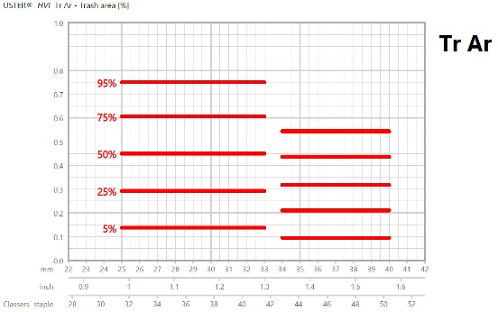

Figure 24: Trash Area vs Upper Half Mean Length (UHML) [Uster].
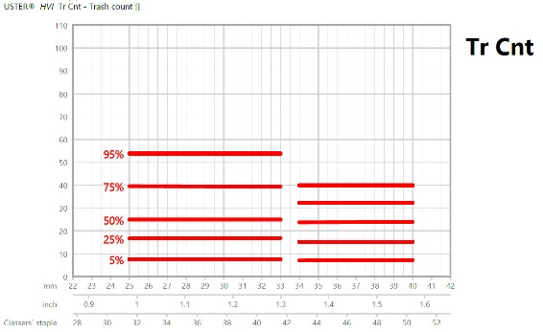

Figure 25: Trash Count vs Upper Half Mean Length (UHML) [Uster].

Existing measuring instruments for measuring trash

Table 14: List of instruments measuring trash.
Instrument | Machine type | Additional linked measured characteristic(s)*
Modules in high volume testers | Uster, Premier, MAG SITCs, Contest-F | Length, strength, micronaire, color …
Stand alone instrument | Uster 760, TexTechno Optotest  Shirley Tester, Premier G-Trash, Uster MDTA 3, Textechno MDTA 4 | TexTechno Optotest: color, neps
*Depending of the model used.

Description of any relation between ‘manual and visual grading’ and ‘instrument classing’ evaluation results
For Upland cottons, Trash count and trash area are often converted to instrument leaf grade in lieu of manually determined leaf grade. Some instruments internally calculate and provide the instrument leaf grade as an additional parameter. Additionally, some organizations, such as USDA, utilize their own instrument to leaf grade conversions based on instrument testing (Table 15).

Table 15: Conversion between trash area and leaf grade.
Classer's Leaf Grade | HVI Trash % Area Limits
1 | < 0.18
2 | < 0.28
3 | < 0.44
4 | < 0.63
5 | < 0.87
8 | < 1.14
7 | < 1.42
8 | >= 1.42
Trash content measured by the HVI has a good relation to the Leaf Grades determined by manual classing in comparison with the Universal Standard boxes. Due to the increasing frame of the lower grades descriptions used for instrumental testing, manual classers may give a more detailed grading of the cotton than the Leaf Grade provided by the HVI.
There is hardly any fixed relation between the established physical standards and the values measured by the HVI in respect of standards from other origins than the USA. A comparison only is possible if based on experience and historical quality outturns.
The evaluation of the trash content by manual classing can differ from the HVI Leaf Grade results due to the type of the trash content.

Evaluation results present in ‘manual and visual grading’ but missing in ‘instrument classing’ evaluation results
Manual classing can separate the trash in its different aspects like the amount of leaf, leaf size and the share of extraneous matter. In contrast, in the HVI tests for upland cotton counts the trash area only for the determination of the leaf grade depending on the origin of the cotton.
Especially extraneous matter, parts of the cotton plant except fibers, is often included in the physical standards boxes of cotton producing countries other than the USA.
Most of the foreign matter in a cotton sample, dirty parts and gin faults can be detected by visual inspection of samples only.

Use of Trash count and area results for cotton production
Trash measurements provide the grower with information regarding management decisions including seed variety selection and harvesting techniques. Different varieties of cotton have different leaf characteristics. For instance, hairy leaf cotton varieties tend to have more trash content than smooth leaf varieties since hairy leaves stick to cotton lint more than smooth leaves. Regarding harvesting, trash content in mechanically harvested cotton typically is higher than in manually harvested cotton. Effectiveness in leaf defoliation for mechanically harvested cotton can also be assessed with trash measurements.
In many countries where the majority of the cotton is still hand-picked, a few established seed-cotton standards are used to class the farmer’s production and to decide about the level of premium or discount to be applied. Usually these established seed-cotton standards reflect color, trash content and some other quality parameters of the seed-cotton. These standards are physical boxes. Instrumental readings usually play no role at this stage.

Use of Trash count and area results in ginning
Trash measurements provide the gin with valuable information to make process control decisions to optimize the balance between trash removal and fiber quality. The optimal balance between improving leaf grade (reducing trash amount) and preserving fiber quality must be found in order to maximize bale value.
The introduction of mechanical harvesting, and the resultant practice of once over harvesting with the aid of chemical boll openers and defoliants, has led to trashier, more variable and sometimes higher moisture content cotton being delivered to the gins. This has led to more extensive drying and cleaning systems and, as the grade still plays a crucial role in determining the price paid for cotton, gins are often forced to over clean the cotton to achieve a high grade which results in a higher price being paid for the cotton lint, and therefore a better return for the grower. Aggressive mechanical lint cleaning combined with heat can be very effective in reducing the trash content, this is often to the detriment of fiber quality, as this can adversely affect fiber length and uniformity, neps and SCF levels and size, as well as short fiber levels, which will affect the textile performance and value of the cotton.
Bale weight is another factor that must be considered in bale value calculations as the degree of trash removal affects the marketable weight of the bale. Aggressive mechanical lint cleaning can reduce bale weights by up to 60 pounds (27 kg) and reduce gin turn out by up to 2%.
The visual inspection of seed cotton and a manual grading in connection with an appropriate separation and a carefully blend of different seed cotton deliveries may help to homogenize the produced bales of cotton at the gin.

Use of Trash count and area results for trading
In respect to the international trading of raw cotton, trash content is usually considered in a contract as part of the grade guaranty, represented by an agreed standard or a type adjusted sample. In this case, trash and color are usually considered to represent about half of the value each.
In some countries, trash weight in percent is commonly part of the quality guaranty in a contract. The testing method has to be agreed in a contract.
As far as the crop of a country is evaluated by HVI testing, it may happen that a separate guaranty for the trash content is agreed based on the Universal Cotton Standards representing the Leaf Grade.
Trash content can be an important part of the delivered weight and its type can influence the further processing. In addition high trash content can be a first indication for other possible quality defects.
Generally spoken, a high content of small leaf particles reduces the grade descriptions similar to a higher content of extraneous matter. Except in the case of some cotton associations for which a trash percentage should be agreed, there are most of all no special discounts for the trash content only. The value differences for grade have to be considered.

Use of Trash count and area results for spinning mills / textile processing
Knowledge of trash content in the cotton bale is important for spinning mills. Any trash remaining in ginned cotton is a waste product to the mill and must be removed during mill processing. Impacts of trash content are realized from the amount of trash removed in the blow-room and in the carding and combing processes. In spinning, trash influences yarn quality with respect to defects as well as lower spinning efficiencies and the number of yarn end breaks. Higher trash contents also affect the cost of the raw cotton bale material to the mill. Mills purchase cotton bales based on total bale weight, which includes both fiber and trash. High trash contents mean that the mill is paying for more trash in proportion to the desired cotton fiber.

Other measured parameters

Spinning Consistency Index
The Spinning Consistency Index (SCI) is an integral parameter of high volume instrument (SITC) results, including all measured SITC test results of one measurement. The SCI is based on regression calculations between SITC measured fiber properties and ring-spun yarn properties, including 160 samples per year in 5 consecutive years. The range is covering length from at least 24 to 35mm, strength from 18 to 36 g/tex, Micronaire 2.8 to 5.8.
Similar SCI of two samples means that the achievable yarn properties from these to samples are similar. The use of SCI will simplify the warehouse management.
The SCI can ideally be used for taking all fiber properties into account in bale management systems. By using SCI, the raw material consistency can be maintained and the raw material variation within and between laydowns be controlled. Practically, the spinning mill will use some specific properties (like Micronaire) plus the SCI for covering all other relevant properties (see chapter 5).
The formula of the SCI is (in HVI calibration mode):
SCI = -414.67 + (2.9 x Strength) – (9.32 x Mic) + (49.17 x UHML in inch)
+ (4.74 x Uniformity Index) + (0.65 x Rd) + (0.36 x +b).
If no color mode is installed, then the SCI equation is:
SCI = -322.98 + (2.89 x Strength) – (9.02 x Mic) + (45.53 x UHML in inch)
+ (4.29 x Uniformity Index).
In case that UHML is given in mm instead of inch, then the constant for UHML (49.17 or 45.53) has to be divided by 25.4.
Currently SCI is solely used for cotton processing, although it is a suitable parameter for getting a first impression of the bale quality and the quality variation between bales for trading purposes, too.
The typical range of SCI is between 100 and 150 for lint, but can be down to 50 for very short/weak samples, or can exceed 200 for very long/strong samples.
Significance at CSITC: currently not at CSITC.
This characteristic has nothing to do with manual classing, and, as far as known, there is no relevance for the international trade.

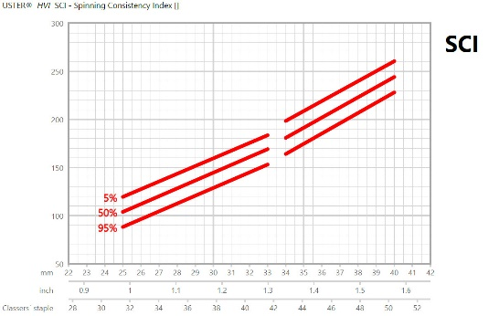

Figure 26: Spinning Consistency Index vs Upper Half Mean Length (UHML) [Uster].

Amount
‘Amount’ is an indication of the quantity of fibers given in the actual test specimen ("comb") when measuring with the length/strength module of the SITC instruments.
A low amount means that not all of the width of the comb is used and/or gaps in the beard might be given. So, not sufficient fibers are given, and hence the strength measurement is less precise. A high amount means that many fibers are on above each other in the optical system, hence introducing systematic deviations.
Typically, the allowed limits for the amount are set in the instruments from 350 to 750. Beards exceeding this range are automatically excluded from the measurement / results.
There is absolutely no use of this information for commercial purposes. Hence the amount result should not be part of any result certificate or a calculation for any purpose in the cotton value added chain.
Significance at CSITC: currently not at CSITC.
This characteristic is not used for trading or manual classing.

Moisture
The standard test method for high volume testing of cotton defines that samples have to be conditionned to their moisture equilibrium before testing (ASTM D 5867). The according suitable temperature and humidity conditions of the laboratory during testing are fixed with 21°C +/- 1 and 65% humidity +/-2 (ASTM D1776).
Typically, cotton samples show an equilibrium moisture content of in average 7.5% with these conditions, with a typical range from 6.75 to 8.25% (dry weight basis). Immature cotton samples tend to absorb less moisture than mature cotton; and extra fine cotton samples (G. Barbadense) tend to show a slightly lower moisture content, too. Both may result in the measured moisture content being on the lower level of the range, or even slightly below.
With the moisture content result provided by the instrument (given on dry weight basis), it can be seen if the actual moisture content of the specimen is inside the typical range of the equilibrium moisture content. Nevertheless, the requirement for testing is the proper conditioning to equilibrium moisture content of the specific sample at 21°C /65%, and NOT the given sample moisture content.
Assuming a proper quality management of the laboratory, including proper air conditioning and sample conditioning, the moisture content has no relevance for the later use of the test results, but solely for the laboratory to assure proper conditioning.
In addition to the measurement of the moisture content in the SITC, the moisture content should in cotton testing laboratories be measured with separate hand-held moisture measurement devices (usually based on electric resistance measurement)
- before the samples are conditioned in order to assure conditioning from the dry side
- before SITC testing, as the SITC moisture information is only given with the test results and not in advance.
The moisture content of the samples in the laboratory doesn't reflect the moisture content of the bale, as the samples are adapting their moisture content quite rapidly to the given conditions.
Significance at CSITC: currently not at CSITC.

Use of Moisture results in production
High humidity or rain during harvest or storage of the cotton may cause a discoloration of the cotton fiber. Machine picking of wet cotton can cause twists and knots and influence the preparation of the ginned cotton.

Use of Moisture results in ginning
An independent topic is the moisture content of the seed cotton during ginning. Of the various ginning parameters, fiber moisture content and lint cleaning, separately and in combination, mainly determine lint quality and subsequent processing performance, in terms of ends down and yarn strength. The moisture content of seed cotton is particularly important in the ginning process. Seed cotton with high moisture content (≥ 12%) will be more resistant to fiber breakage, but trash will be harder to remove, with the seed cotton also not being separated effectively into smaller clumps which could cause blockages and damage to the machinery. Alternatively, seed cotton that is too dry (≤ 4%) will cause blockages and damage to the machinery, due to the generation of static electricity. Also, low moisture content will lead to the fiber becoming stiffer, more brittle and weaker, resulting in potentially more fiber damage during the ginning process. When excessive fiber cleaning and drying are dispensed with, only half as many neps form during the mechanical processing of cotton into yarn, yarn spinning breaks are reduced by 50% and yarn strength and uniformity improve by about 15%.
It is recommended that the ideal/optimum fiber moisture content during ginning should be 6 to 8% for Upland cotton and 5 to 6% for ELS. This is a compromise between smooth and effective cleaning on the one hand and fiber quality preservation on the other. In general, therefore, ginning at a moisture content below 5% can cause serious damage to the fibers, while ginning cotton with a moisture content above 8% may produce a rougher lint (poor preparation), decreased gin capacity and less effective cleaning

Use of moisture content for trading
In the first instance high moisture content is a problem in respect of weight. Normal moisture content of a bale is considered to be between about 7 - 9% at the time of arrival at destination depending of the climate conditions. Higher moisture content increases the weight the buyer has to pay for, without having more cotton fibers. The weight loss can be claimed. Longer exposure of cotton to water from the outside can cause country damage which will be considered in the weight settlement between buyer and seller or covered by insurance.
Pressing of parts of wet cotton can cause caked cotton at various parts of a bale. Generally pressing bales of cotton with a higher humidity may cause a discoloration of the cotton, if the bales are stored for a longer period of time. It will affect color grade and causes a price discount at the end. The value differences for grade are applicable then.
But the moisture content has to be measured directly at the bale or in properly packed and sealed bags that avoid any moisture to get into or out of the sample before moisture testing in a laboratory. For measuring moisture directly at the bale, usually either electric resistance with a 2-needle sensor or microwave measurement are used. For measuring moisture of sealed samples in the laboratory, usually the oven-method is used. Alternatively, specific microwave systems are available.
Samples that were drawn for SITC testing are not suitable for determining the moisture content of the bale.
Based on the actual weight of the bale and the measured moisture content, the commercial weight is calculated. The legal moisture regain, which is the moisture content dry basis, is fixed to 8.5%.
In addition, country Damage or caked parts may be signs for higher moisture content in parts of a bale. The touch of a sample, deep yellow spots and the smell sometimes give the first indication for a higher than usual moisture content in a cotton sample. The exact degree of humidity has to be measured by a testing instrument. A discoloration of cotton because of higher moisture content will be considered in the manual grading.

Other characteristics that could be measured on fibers using other instruments

Neps
Neps are generally defined as small knots of entangled fibers and occur mostly in the form of fiber neps or seed coat neps. A fiber nep is comprised of a knot of tangled immature or dead fibers while a seed coat nep is an entanglement of fibers attached to a fragment of seed coat. Neps can also be distinguished as either mechanical or biological. Mechanical neps are classified as those made up of only entangled fibers while biological neps are those containing entangled fibers attached to a foreign matter particle fragment such as a seed coat, husk, stem or leaf.
Neps in raw cotton can be created by several factors including the growing environment of the cotton plant, plant variety selection, and fiber processing during harvesting, ginning and textile processing. Given the entangled and knotted nature of neps, they are generally considered as a contaminant and reduction of neps at the mill is therefore necessary to reduce quality defects in yarn and fabric.
Another type of nep is a white speck nep that shows up as dye resistant neps in fabric. These neps are made up of tangled immature fibers. Immature fibers lack sufficient secondary wall development and therefore have low cellulose content which is necessary for dye uptake.
Finally, sticky neps are entanglement of any mature or immature fibers maintained as fiber nep by the presence honeydew deposit that glue involved fibers together.
Nep content is measured in terms of the number of neps per gram and the mean nep size. Some instruments are capable of providing these measurements separately for fiber neps and seed coat neps.

Unit, range, significance in CSITC harmonization process
Nep count per gram, mean nep size in microns
Short name or abbreviation: Nep count and nep size
Usual range for nep count of raw cotton is between 150 to 400 neps/gram. Usual range for the average nep size is 600 to 700 microns. With regards to seed coat neps, the usual range for seed coat nep count is 10 to 40. The usual range for seed coat nep size is 1000 to 1300. These figures are test results on raw cotton and indicative only. The amount of neps in a yarn or a fabrics depends also from the treatment of the cotton during the processing steps.
Significance at CSITC: currently not at CSITC.

Table 16: Categorization of neps according to their number.
Neps / gram | Seed Coat Neps / Gram | Description
< 100 | < 10 | Very low
101 - 200 | 11 – 20 | Low
201 – 300 | 21 – 30 | Medium
301 – 450 | 31 – 45 | High
> 451 | > 46 | Very high

Existing measuring instruments for measuring Neps

Table 17: List of instruments measuring neps.
Instrument | Machine type | Additional linked measured characteristic(s)*
Stand alone instrument, fiber per fiber | Premier aQura | Short fiber, gravimetric trash
Stand alone instrument, fiber per fiber | Uster AFIS | Length, trash, short fiber, fineness, maturity
Stand alone instrument, fiber per fiber | Uster LVI 920 Neptester | No
Stand alone instrument | TexTechno MDTA4/Optotest | Trash, color, length, stickiness
*Depending of the model used.

Description of any relation between ‘manual and visual grading’ and ‘instrument classing’ evaluation results
The largest neps, in general, are about twice the size of a pinhead. Therefore, small neps in raw cotton are most of all not visible to manual classers. Larger knotted entanglements are readily visible to classers. A general description in respect of fiber crimp, fiber neps, seed coat neps, fiber twists and fibers attached to other particles is possible by classers. The staple pulling provides a first impression about the content of fiber entanglements, but a more exact measurement is possible by instrumental testing only.

Evaluation results present in ‘manual and visual grading’ but missing in ‘instrument classing’ evaluation results
The preparation and the number of twisted or entangled fibers can give a first indication about the potential creation of neps during processing besides the already existing and measurable neps.

Use of neps results for cotton production
Picking cotton early before bolls are allowed to properly mature increases the number of immature fibers resulting in an increase in neps. Late picked cotton can also have increased nep content due to weakened fiber resulting from over exposure to sun and moisture. Additionally, late picked bolls have a higher proportion of immature fiber and undeveloped seeds which increases nep content.
Seed-coat neps are variety and growing conditions related, and breeding programs may improve the situation.

Use of neps results in ginning
Immature bolls are typically removed early in the cleaning process at the gin. Immature bolls are not extracted can be broken open during the ginning process releasing and mixing immature fibers with mature fibers. The resulting mix of mature and immature fibers will result in higher nep content.
Seed-coat fragments are created when breakage of the seed-coat occurs during ginning. Fibers attached to the fragments of seed-coats form seed-coat neps. Seed-cotton with low moisture content is susceptible to seed-coat breakage during harvesting and ginning. In addition, some cotton varieties have weak seed coats that can break apart easily.

Use of neps results for trading
The use of a neps guaranty in contracts is not usual in the international trade. Test results may be provided to buyers as an indication. In rare cases, the allowed number of neps is mentioned in a contract based on a test result provided earlier based on an agreed applicable test device. It is recommended to use the same method and preferably the same device in a laboratory to re-check results.
In general words, there is a lack in testing speed, precision, accuracy and in harmonization of the results of the available devises. In addition, these methods may be more expensive than HVI testing and not suitable for testing big volumes. The usually performed number of tests also limits the value of the tests results.

Use of neps results for spinning mills / textile processing
Most neps in the textile process are created in the blow room where the rolling of cotton tends to entangle fibers into neps. Carding does a good job of reducing neps but also creates some new neps in the process. The combing process also does a good job of removing neps according to AFIS® results. Proper setting and use of textile machines will reduce the creation of and increase the removal of neps. Typical behavior of nep increase and removal are also depicted in the Statistics application of USTER.

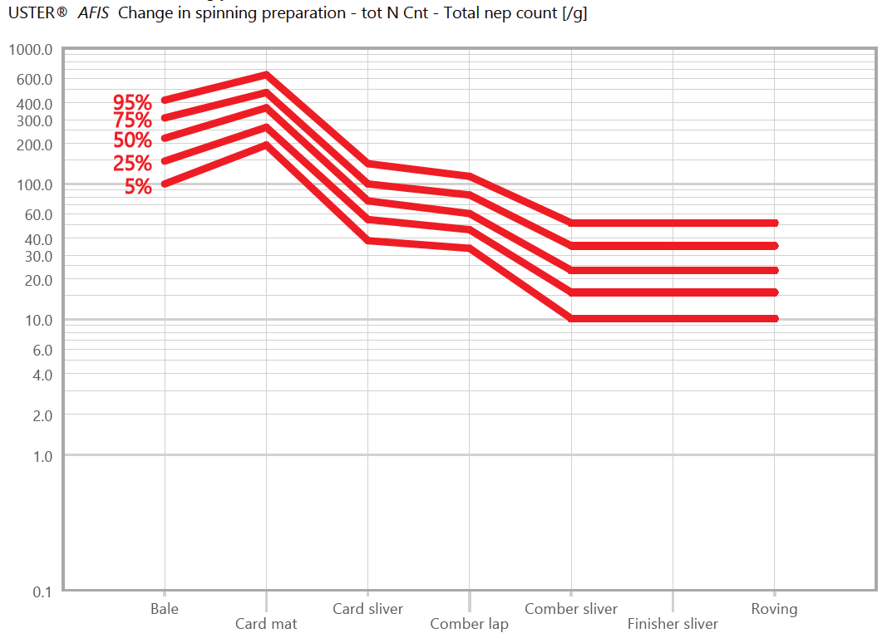

Figure 27: Evolution of AFIS® nep count through various processing steps [Uster].

Stickiness
Stickiness originates from various sources: vegetal parts, oil traces, waxes, plant sugars and insect sugars. The most important and problematic cause of stickiness is due to the entomological sugars from insect secretions. Stickiness induces productivity and quality losses as sticky points remain in the material from fibers in the field to the textile processes.
The behavior of contaminated fibers during processing is highly dependent upon the quantity and the type of the main and complex sugars present in fibers in relation to the transformation machine types and settings as well as on the ambient conditions of transformation.
Various techniques may be used to estimate a possible contamination of fibers by honeydew, expecting that these methods measure a same property of the fibers, which should be in relation to “the propensity to fibers to stick to spinning parts during their processing”. According to the latest results, this has to be confirmed for several currently used methods.

Unit, range, significance in CSITC harmonization process
There is no universal unit or range for stickiness measurement, as each technique has its own unit, range and level.
Short name or abbreviation: None
Usual range: the units reflect the stickiness level of the tested fibers from no stickiness to heavy stickiness.
Significance at CSITC: currently not at CSITC.

Existing measuring instruments for measuring stickiness

Table 18: List of instruments measuring stickiness.
Instrument | Machine type | Additional linked measured characteristic(s)*
Contest-S | Thermomechanical
Contest-F | Thermomechanical | Fiber characteristics such as Length and Strength (UHML, UI, Strength, SFI, Elongation), Moisture, Color (Rd, +b, Grade), Trash (Count, Area, Leaf), Micronaire, Maturity, Fineness
High Speed Stickiness Detector (H2SD) | Thermomechanical
Mini-card** | Mechanical
Sticky Cotton Detector (SCT)*** | Thermomechanical
*Depending of the model used.
**ITMF-ICCTM Reference method (1986), the one to which all other methods’ results should be compared.
***ITMF-ICCTM Recommended method (1994).

Description of any relation between ‘manual and visual grading’ and ‘instrument classing’ evaluation results
It seems that this is not possible to evaluate any stickiness by manual or visual grading unless fumagine developed of fibers; fumagine looks as a black deposit onto fibers and is the results of the development of fungi on the honeydew of the fibers. This only occurs when initial honeydew content is very high on the fibers. Therefore, only in rare cases, a manual inspection may reveal the first suspicious indications of higher stickiness, such as the degree of yellowness, if the normal characteristics of cotton from a certain origin are known. Later, after fumagine finishes developing, fibers are generally not sticky anymore, but the intrinsic cellulose of the fibers may have been affected during the storage time.

Evaluation results present in ‘manual and visual grading’ but missing in ‘instrument classing’ evaluation results
No organoleptic appreciation can clearly identify stickiness in cotton samples with high reproducibility proven in a scientific way. However, it may be that some very extremely contaminated samples with stickiness could be detected by a very sensitive manual perception.

Use of stickiness results for cotton production
As stickiness measurements are usually made on fiber samples, therefore after picking and ginning, it is almost too late to have actions on the cotton production side by controlling insect populations in cotton fields, unless to plan detections of insects in the fields and actions to limit insect infestations for next cropping seasons.

Use of stickiness results in ginning
Nowadays, stickiness characterization is made on fiber samples, which only can be taken after the ginning operations. Therefore, no ‘predictive’ measurement can be done from seed-cotton samples to predict seed-cotton processing at the gin in the stickiness dimension.
There are essentially two types of cotton ginning techniques, namely saw and roller ginning. Saw gins are generally used to process Upland type cottons of short to medium staple length (˂ 25.4 mm to 31.0 mm) and is consequently the most prevalent type of gin in the world. All Extra Long Staple (ELS) cottons (≥ 35.0 mm) are ginned on roller gins, and, in addition, it is estimated that, currently, 15 to 20% of Long Staple Upland (LS) and medium staple cottons (≥ 27 mm) are also ginned on roller gins.
Roller-ginned cotton is adversely affected by moderate levels of stickiness while saw- ginned cotton is less sensitive to moderate levels of stickiness and is usually first detected in the textile mill . Roller gins are more susceptible to stickiness due to their design, with the ginning process reliant on friction, and a build-up of sticky spots on the ginning roller and the stationary knife will result will result in a decrease in ginning efficiency.
Saw ginning does not rely on friction but on the mechanical pulling of fiber by saw teeth through two closely spaced ribs and thus moderate levels of stickiness will not affect production rates. In terms of saw ginning, sticky deposits can clog the saws in the saw gin and disrupt the baling process due to accumulation of lint on the lint slide of the battery condenser. This disruption can reduce gin production in bales/hour by up to 25%, or up to 15 pounds per hour for roller ginning, which is about 50% of the normal rate of roller ginning. These disruptions result in longer and more expensive ginning seasons, due to higher labor costs and additional spare parts, as saws and blades need to be replaced more regularly.

Use of stickiness results for trading
Stickiness measurement results on bale samples are assumed to predict the fiber behavior during their processing at the spinning mill, especially at the most critical steps which are when the fiber flow becomes thinner (from the card on). It has been shown that knowing the stickiness potential of cotton fiber bale from sample testing helps in managing the bale lots according to at least two categories based on a given threshold: not sticky and sticky. From there, bale lots can be traded according to their real quality and their according financial value, not only based on the reputation. In consequence, the production side could organize sales lots based on stickiness characterization results in order to properly feed his customers and help in improving the cotton production by medium/long-term remediation actions.
However, the current testing methods for stickiness are missing testing precision and accuracy for use in quality guarantees. Despite the ITMF recommendations, there are various methods available. The evaluation results may serve well in a local context, but not for the international trade due to high differing results on different samples and testing devices that are not acceptable. The lack of repeatability of tests, the dissenting interpretation of results, the costs of tests as well as the not very common use at origin may cause a high risk for contract parties.

Use of stickiness results for spinning mills / textile processing
Knowing the stickiness level of cotton bales for organizing bale laydowns helps to manage the raw material so that the adhesive effect is not perceived in terms of productivity and/or quality later on. It has been shown that the mixing of non-sticky cotton with sticky cotton on one side, and the management of ambient air conditions in the spinning rooms on the other side greatly reduce the impact of stickiness on the spinning process and the yarn quality.

Interaction or relations between parameters

In this version of the document, even though we all know that interactions between fiber properties may explain many observations, it has been decided to first not consider that difficult addition.

It is planned that some of these typical relationships between fiber and yarn characteristics that textile industry knows well will be explored in later versions of the document.

As an example of possible interaction to be explored: a cotton with low UI has a high short fiber content, that induces a higher hairiness and lower evenness CV, usually leading to a lower yarn strength at least, all this having implications on finishing efficiencies and fabric properties. Reasons for observing such interaction in this example could be a combination of one or several of the followings: alteration of production conditions, alteration of ginning conditions, alteration of spinning conditions… and this has consequences up to the final product properties.

We will welcome ideas and data to explain and demonstrate such interactions; for this please get in touch with one or more of the contributors of this document for preparing insertion in next version of this document.

Summarized information
This document attempts to provide both theoretical and practical information on the use of standardized instrument testing for cotton (SITC) devices. Latest knowledge about is described about the major fiber characteristics measurement. Also are given some practical ideas on how to use SITC characterization results by all users of the cotton industry, namely, producers, ginners, traders, classers, spinners and beyond.
For spinning, in the former chapters the influence of each property has been considered. Already from here, we know that not only one fiber property is influencing each yarn property. Instead, each fiber property influences several yarn properties at the same time. Looking the other way around, each yarn property is influenced by several fiber properties. A very simplified overview about the relations is given in Table 19.

Table 19: Influence of fiber properties on yarn quality properties [USTER].
 | Evennness CVm | Thick places | Thin places | Neps | Hairiness | Strength | Elongation | Appearance | Dyeability
Micronaire/Fineness | XX | XX | XX | XX | XX | XX | XX | XX | XX
Maturity | XX | XX | XX | XX | - | XX | XX | XX | XX
Length | XX | XX | XX | XX | XX | XX | XX | XX | -
Short Fiber Content | XX | XX | XX | XX | XX | XX | XX | XX | -
Strength | - | - | - | - | - | XX | XX | - | -
Elongation | - | - | - | - | - | XX | XX | - | -
Nep content | X | - | - | XX | - | - | - | XX | XX
Dust & trash content | X | XX | XX | XX | - | XX | XX | XX | -
Color/color deviation within lot | - | - | - | - | - | - | - | XX | XX
X: explain; XX:explain; - explain
In addition, it is possible to influence the yarn properties in several stages of the spinning process. It might be the bale laydown (and with this the fibre properties), or in any other stage of the spinning process. Again, a simplified overview is given in Table 20.

Table 20: Influence of process stages in ring spinning operations on yarn quality properties [USTER].
 | Evennness CVm | Thick places | Thin places | Neps | Hairiness | Count | Strength | Elongation
Bale Lay-down | XX | XX | XX | XX | XX | - | XX | XX
Blowroom | XX | XX | XX | XX | - | - | XX | XX
Card | XX | XX | XX | XX | XX | XX | X | X
Drawframe | X | XX | X | X | - | XX | X | X
Comber | XX | XX | XX | XX | XX | - | XX | XX
Roving frame | X | X | X | - | X | X | X | X
SpinninG frame | X | X | X | X | X | X | X | X
Winding machine | X | X | X | XX | XX | - | X | XX
X: explain; XX:explain;- explain
For the fabric, usually the fibre properties are not of interest anymore. The weaver has to base on the suitable properties of the yarn he uses. Only for dyeing can a direct relationship between fibre properties and fabric properties be easily detected. Else it is more important to consider the correlation between yarn properties and fabric properties. This is shown in Table 21.

Table 21: Influence of yarn properties on fabric characteristics [USTER].
 | Appearance | Dimensional stability | Thickness | Hand  /Drapé | Pilling | Ward and weft breakage rate | Holes, knitting | Spiralty | Dyeability/color, intensity, fastness | Wash and wear properties | Strength | Elongation
Mass variation CVm | X |  |  | X |  | X | X |  | X |  | X | X
Thick places | X |  |  | X |  | X | X |  | X
Thin places | X |  |  | X |  | X | X |  | X
Neps | X |  |  | X |  |  |  |  | X
Hairiness | X |  | X | X | X | X |  |  | X | X
Hairiness variation | X |  | X | X | X | X
Diameter | X |  | X |  |  |  |  |  | X
Diameter variation | X |  |  |  |  |  |  |  | X
Shape | X |  | X |  |  |  |  |  | X
Density | X |  | X | X |  |  |  |  | X | X
Trash, Dust | X |  |  |  |  | X | X |  |  |  | X
Strength |  | X |  |  |  | X | X |  |  |  | X
Elongation |  | X |  |  |  | X | X |  |  |  | X | X
Twist | X | X |  | X | X | X | X | X |  | X | X | X

Lexical

CSITC-TF: Commercial Standardized Instrument for Testing Cotton, Task Force of the ICAC
CSITC Testing Guideline, Guideline for Standardized Instrument Testing of Cotton
HVI®: Protected wording for High Volume Instruments produced by Uster® Technologies Inc..
ICAC: International Cotton Advisory Committee
ITMF: International Textile Manufacturers Federation
ITMF-ICCTM: ITMF International Committee on Cotton Testing Methods
ITMF-ICCTM and CSITC Interpretation Guideline: Interpretation and use of SITC measured characteristics Guideline
SITC: Standardized Instrument for Testing Cotton for replacing the wording ‘HVI’ which is a protected name.

Any addition ???

Acknowledgments
Bruno Bachelier, Cirad, France, for his valuable comments during the reviewing phases of this document.
Courtesy of Uster Technologies for the use of USTER® STATISTICS for cotton (www.uster.com/statistics2018) in most chapters of this document.
Cotton Incorporated for designing the cover page of this document.
International Cotton Advisory Committee, for his support to the CSITC-Task Force.
International Textile Manufacturers Federation, for his support to the ICCTM.
All Organizations supporting the presence and attendance of their Experts to all working groups working at the harmonization of fiber quality assessments.
All Interpreters for translating the official English book into other languages similarly to what has usually been done for the ‘CSITC Testing Guide’.

List of illustrations
Figure 1: Cotton and textile supply chain: major materials flows. 7
Figure 2: Various calculation ways for Means and Standard Deviations (SD) in the case of bale management: Influence of the calculated mean and SD values (explanation in Annex A). 9
Figure 3: Various calculation ways for Means and Standard Deviations (SD) in the case of round-tests results: Influence of the calculated mean and SD values (explanation in Annex A). 10
Figure 4: Using a bale-opening machine, examples of two cases for organizing the bales into the successive batches to be processed: Case 1: all bales from one origin are processed before processing bales from another origin up to its exhaustion and so on; Case 2: bales from various origins are randomly (or at purpose) dispatched between several successive batches. These examples have to be extended as laydowns could have up to around 15 origins and to 100 bales in the real life. 13
Figure 5: Examples of distributions for four origins (Simulated Mic), and one proposal of organization of bales in the 50 successive laydowns (100 bales each) feeding a spinning mill. 14
Figure 6: Micronaire results of successive laydowns (100 bales each) fed to a spinning mill taking care of the combination between technique used and organizations of the laydowns. Table provides statistics of differences between successive laydowns in the two proposed cases. 15
Figure 7: Evolution of within-laydown variations (SD or CV) along time depending on the studied case. 16
Figure 8 : Optimization of bale laydown and its results: Bale laydown optimization based on SCI and Micronaire starting in week 22, and according change in yarn strength: Yarn Strength, [Uster: HVI Application Handbook]. 17
Figure 9: Optimization of bale laydown and its results: Bale laydown optimization based on SCI and Micronaire starting in week 22, and according change in yarn strength: Yarn strength CV% [Uster: HVI Application Handbook]. 17
Figure 10: According to the central limit theorem, using a distribution of mean values instead of a distribution of single values will lead to a normal distribution with a lower variation [Uster: Uster Tester 6 Application Handbook]. 18
Figure 11 : Courtesy of Uster Technologies: USTER® STATISTICS for cotton (www.uster.com/statistics2018): Micronaire vs Upper Half Mean Length (UHML). 20
Figure 12: Micronaire (X) vs. fineness (H) (linear density in millitex (mg/km)) values for bales of cotton in a laydown prepared for fine count (Ne 50) ring spun yarn. Values are separated into maturity ratio (MR) values according to the legend. 21
Figure 13: Example of combination of maturity (MR, no unit) and of linear fineness (H, mtex) complex for a same Micronaire reading: for fibers with a micronaire value of 4.1, fibers could be fine and mature or immature and coarse. Standard fineness (Hs, in mtex) is the ratio of maturity to the linear fineness. 22
Figure 14: Fibrogram and related information. 27
Figure 15: Uniformity Index vs Upper Half Mean Length (UHML) [Uster]. 28
Figure 16: Short fiber index vs Upper Half Mean Length (UHML) [Uster]. 28
Figure 17: Fiber length distribution in a drafting zone. 31
Figure 18: Strength vs Upper Half Mean Length (UHML) [Uster]. 33
Figure 19: Elongation vs Upper Half Mean Length (UHML) [Uster]. 33
Figure 20: The Nickerson-Hunter cotton colorimeter diagram for Upland cotton; Source: http://www.cottoninc.com/fiber/quality/us-fiber-chart/hvi-color-chart/. 37
Figure 21: Yellowness vs Upper Half Mean Length (UHML) [Uster]. 38
Figure 22: Reflectance vs Upper Half Mean Length (UHML) [Uster]. 38
Figure 23: An example of physical standards for Color Grade . 41
Figure 24: Trash Area vs Upper Half Mean Length (UHML) [Uster]. 44
Figure 25: Trash Count vs Upper Half Mean Length (UHML) [Uster]. 44
Figure 26: Spinning Consistency Index vs Upper Half Mean Length (UHML) [Uster]. 49
Figure 27: Evolution of AFIS® nep count through various processing steps [Uster]. 55

List of tables
Table 1: Within-Instrument Variation on one sample: Median within-instrument Standard Deviation (SD), averaged for 32 US Upland cotton samples from RT 2017-1 to 2018-4. 11
Table 2: Within-Instrument Variation: Median within-instrument Coefficient of Variation (CV%), averaged for 32 US Upland cotton samples from RT 2017-1 to 2018-4. 11
Table 3: Within-Instrument Variation on one sample: range of within-instrument Standard Deviation (SD) for eight Round Trial Sample Bales from ICA Bremen RT 2016-1 to 2018-2. 12
Table 4: Table of between instrument variations as reported by the CSITC Testing Guideline (extracted). 12
Table 5: Foreseen consequences when changing the organizations of the bales in the laydowns. 14
Table 6: List of instruments measuring micronaire. 23
Table 7: List of instruments measuring length. 29
Table 8: List of instruments measuring strength. 33
Table 9: Interpretation or classification of strength results. 34
Table 10: Interpretation or classification of elongation results. 34
Table 11 : Priorities and significant parameters for the different spinning systems. 35
Table 12: List of instruments measuring color parameters. 39
Table 13: Color grades of Upland cotton (* - Physical standards for color grade # - Physical standards for leaf grade). 41
Table 14: List of instruments measuring trash. 44
Table 15: Conversion between trash area and leaf grade. 45
Table 16: Categorization of neps according to their number. 52
Table 17: List of instruments measuring neps. 53
Table 18: List of instruments measuring stickiness. 56
Table 19: Influence of fiber properties on yarn quality properties [USTER]. 60
Table 20: Influence of process stages in ring spinning operations on yarn quality properties [USTER]. 61
Table 21: Influence of yarn properties on fabric characteristics [USTER]. 61

ANNEX A: Detailed explanation of Figure 2
(and similarly of Figure 3)

The following example (Figure 2, top of figure… for the theory, and in the table below for a simple application) is based on the testing of one lot/batch of two bales. At the basis, two samples are taken per bale, and three test results are collected for each sample.
- To calculate mean and standard deviation (SD) at the sample level, test results are directly used (ref. 1 and 2) and every sample potentially is different from others.
- To calculate mean and SD at the bale level, at least three calculations are possible:
  - a) based on the test results (mean with ref. 3 and SD with ref. 4),
  - b) based on the sample means (mean with ref. 4 and SD with ref. 6).
  - c) based on mean or median (ref. 7) of previous calculated SDs (ref. 2).
- To calculate mean (ref 8) and SD at the lot level, at least five calculations are possible:
  - a) based on test results (ref. 9),
  - b) based on sample means (ref. 10),
  - c) based on bale means (ref. 11)
  - d) based on mean or median (ref. 12) of previous calculated SD at the sample level (ref. 4)
  - e) based on mean or median (ref. 13) of previous calculated SD at the bale level (ref. 6).
We therefore conclude that all these SDs differ greatly and that we need to know how a specific SD was calculated before comparing it to any other SD.
Taking care of the way the testing is conducted nowadays, the ‘result’ level usually is not available, and one mean and one SD are provided at the ‘sample’ or even the ‘bale’ level only. Therefore, a part of the variability is hidden, not removed, and included into the displayed variability result that is provided to data end-users.
Even though all these numbers and calculation methods seem confusing, they all have their interest at various levels in the supply chain, as they allow the production of a performance diagnostic when needed. For instance:
- Variation measured by ref. 2 calculation gives an idea of the laboratory performance;
- Variation measured by ref. 4 calculation provides an idea of the within-bale variation and therefore about the ginning performance;
- Variation measured by ref. 11 calculation provides an idea of the between-bales variation and therefore about the lot or laydown evenness both in trading and spinning…
The following paragraphs provide some typical mean and SD numbers to illustrate the measured variation levels depending on the assigned objective(s) of the experiments or of the sample testing.
Figure 2 clearly is applicable to bale management, but if slightly modified into Figure 3, is applicable to round-test results analysis for learning more about the laboratory performances. It therefore allows the measurement of typical levels of variation in the results with a good level of certainty, assuming that those typical levels of variation remain at a comparable level in every day testing and trading practices.
For both Figure 2 and Figure 3, the following variation levels (written in dark brown) are included or taken into account into the variances (or SDs) calculated at the following levels:
- Between results and within-sample:
  - measurement + specimen sampling variances.
- Between-samples* and within-bale**:
  - *: measurement + specimen sampling + sample sampling variances;
  - **: measurement + specimen sampling + sample sampling + bale sampling variances.
- Between bales* or Within-lot**:
  - *: measurement + specimen sampling + sample sampling + bale sampling + between-bales variances;
  - **: measurement + specimen sampling + sample sampling + bale sampling + lot variances.

Things may be even more complex, for instance, when additional factors of variation are included, such as for studying the layer effect within bales (meaning that several fiber samples are tested within each layer of a bale), or testing conditions (for instance checking the operator effect of measurement results, or the repetition or block effect), or …

Finally, for statistical analysis, other sources of variation, such as interaction levels between part or all studied factors and residual errors, also are to be considered in addition to those described above.

This figure is only true when the number of data points remains even at all levels (test result, sample and bale levels).
This figure is only true when the number of data points remains even at all levels (test result, cotton, laboratory, and round-test levels).
Figure 3, calculation ref. 2, explained in ANNEX A.
Figure 3, calculation ref. 10, explained in ANNEX A.
Figure 3, calculation ref. 2, explained in ANNEX A.
Figure 3, calculation ref. 10, explained in ANNEX A.
Figure 3, calculation ref. 2, explained in ANNEX A.
A direct link to a ref. in Figure 3 cannot be given as a level of variation ‘Layer’ would have to be added, while it would really complicate the figure.
Origins here stands for representing any source of variation: country of origin, assigned quality group (by characteristic, bale provider, cotton trader…), bale lot arrival, or anything in this nature.
Individual Micronaire readings were simulated according to Gaussian distributions with increasing mean values per origin (A: 3.2; B: 3.6; C: 4.1; D: 4.5) and a common and stable SD value (SD=0.45).
White specks are entanglements of fibers not absorbing much dye, thereby appearing duller or paler than mature fibers on died fabrics.
A cotton fiber is a single, elongated plant cell. The thickness of its cell wall determines the fiber’s maturity. Fiber maturity is a normally distributed property but the distribution is typically negatively skewed such that most samples have a long tail of immature (maturing) fibers. The shape of this tail being largely dependent on growth and harvest preparation conditions (for the cotton plant/crop).
Lord E. 1955. Air Flow through Plugs of Textile Fibers: Part 1—General Flow Relations, Journal of the Textile Institute Transactions, 46:3, T191-T213, DOI: 10.1080/19447027.1955.10750307
With their approval, later on in this Interpretation Guide, reference to this reference will only reminded as follows: [Uster].
Lord E. 1956. Air Flow Through Plugs of Textile Fibers: Part 2, Journal of the Textile Institute Transactions, 47:1, T16-T47, DOI: 10.1080/19447027.1956.10750375
H = hair weight
Meredith, W. R. Jr. 1984. Quantitative genetics In: Kohel, R. J. and Lewis, C. F. (eds) Cotton. ASA, CSSA, SSSA, Madison, pp 127-146
May, O. L. 1999. Genetic variation in fiber quality. In: Basra, A. S. (ed) Cotton Fibers. Food Products Press, Binghampton, pp 183-229
Bange, M., Long, R., Constable, G. and S. Gordon. 2010. Minimizing Immature Fiber and Neps in Upland Cotton, Agron. J., 102, pp 781–789.
‘Growing conditions’ include crop management practices (crop protection, sowing date…), biotic (pests, diseases, weeds…) and abiotic (soil, climate…), environment and their interactions.
Drieling et al.. 2018. Guideline for Standardized Instrument Testing of Cotton”, http://csitc.org/index.php?lien1=/instrument_testing/public_documents_it. Uster Technologies. 2007. HVI Application Handbook.
Schenek A. 2001. Naturfaserlexikon, Spinlab, Knoxville,page 86, Deutscher Fachverlag, ISBN 3-87150-638-9.
Furter R. 2011. Textile Measuring Technology and Quality Control, Uster Technolgies.
Duckett K., Ghorashi H., Zapletalova T., M. D. Watson. 1999. Color Grading of Cotton. Part I: Spectral and Color Image Analysis, Textile Research Journal 69 (11), pp. 878-886.
Matusiak M., A. Walawska. 2010. Some Aspects of Cotton Color Measurement, Fibers & Textiles in Eastern Europe 2010, Vol. 18, No. 3 (80), pp. 17-23.
Anthony W.S., W. D. Mayfield. 1994. Cotton Ginners Handbook, USDA.
A basic guide to cotton pricing and quality, Cotton Info, January 2017, available on: https://www.cottoninfo.com.au/.
Overview of USDA HVI Cotton Classification Standards and Qualification Materials, USDA, available on: < http://cotton.tamu.edu>.
Majumdar M., Majumdar P.K., Sarkar B. 2004. Selecting Cotton Bales by Spinning Consistency Index and Micronaire Using Artificial Neural Networks, Autex Research Journal, Vol. 4, No1, 2004.
Special note: For comber or waste samples (not in the scope of this document), the results can even be lower than zero.
‘Country damage’ is the damage or deterioration of the fiber caused by the absorption of excessive moisture, dust or sand from the exterior because it has been exposed to the weather or stored on wet or contaminated surfaces. This cotton is wasted.
‘Caked cotton' is the description for a damage of clumped parts inside a bale. The pressing of in part excessive moistened or wet cotton under high pressure and the influence of microorganisms cause hard areas in the bale during a longer storage period.
Héquet E. F., R. Frydrych. 1992. Sticky cotton from plant to yarn. In: International Cotton Conference. 21. Montpellier : CIRAD-IRCT, 18 p. International Cotton Conference. 21, Brême, Allemagne, 12 Mars 1992/14 Mars 1992
Bargeron D., J & H. Garner, T. 1991. Cottonseed fragment contamination and fabric imperfections. Transactions of the ASAE. 34. 1575-1582. 10.13031/2013.31772.
Bachelier, B. 1998. Contribution à l'étude de la variabilité et du déterminisme génétique de la teneur en fragments de coque de la fibre de coton. Premières applications pratiques en sélection chez Gossypium hirsutum L. Thèse Biologie et Agronomie 98-32-C-50. Rennes (FR), Ecole Nationale Supérieure Agronomique de Rennes (ENSAR): 271. Bachelier, B. and J. Desplans 1999. Histological examination of seeds and seed-coat fragments in cotton (Gossypium hirsutum L.). Beltwide Cotton Conferences. Orlando, Florida (USA), National Cotton Council of America. Memphis, Tennessee (USA). 1: 724. Bachelier, B. and S. Lassus. 2000. Breeding against seed-coat fragments in cotton fiber (Gossypium hirsutum L.) using image analysis on card web. Beltwide Cotton Conferences. San Antonio, Texas (USA), National Cotton Council of America. Memphis, Tennessee (USA). 2: 1542.
www.uster.com/statistics2018
Existing techniques are probably not all measuring the same property of the fibers. Therefore, as far as we know, the ‘purely stickiness measuring methods’ are listed at this point in this table. All methods participating to the ITMF-ICCTM inter-laboratory round-test for stickiness measuring methods are visible at: https://www.itmf.org/committees/international-committee-on-cotton-testing-methods.
Abdel-Latif A.H. et al. 2009. Effect of irrigation interval and picking time on fiber quality and the degree of stickiness in two cotton cultivar, http://agris.fao.org/agris-search/search.do?recordID=SD2010000119
Fadlalla Ahmed Salih et al. 2004. Possibility of classifying cotton on level of stickiness (separating non-sticky from sticky cotton). In: International cotton conference Bremen: Proceedings 2000, Proceedings 2002, Proceedings 2004. Schneider T. (ed.), Heap S.A. (ed.), Stevens J.C. (ed.). Faserinstitut Bremen, Bremer Baumwollboerse. Bremen: Faserinstitut, 253-261. International Cotton Conference. 26, Brême, Allemagne, March 13/March 16, 2002.
See CFC/ICAC 11 Improvement of the Marketability of Cotton Produced in the Zones Affected by Stickiness at https://www.icac.org/Content/CFCDocument/Pdfc7a2ceed_b571_457b_b407_8dd4489bd57e/2001_Gourlot_Soudan_FinalResearchTechnicalReport1.pdf Hequet E. F., Henneberry TJ, Nichols RL. 2007. Sticky Cotton: Causes, Effects, and Prevention, www.ntis.gov. (accessed April 8, 2019).
The best possible practice for measuring the observed variations is to base all calculations on variances - not on SDs as shown here - as variances add up at the various considered levels of variability. Variance is the square of SD. However, as variances are not easy to foresee, we use SDs as known values to display in this document.
The mean value for the lot (ref. 7) is the same with all calculation methods, as long as the number of data points remains even at all levels (test result, sample and bale).

